**Docker Learning**

**What is Docker?**

Docker is **an open source containerization platform**. It enables developers to package applications into containers—standardized executable components combining application source code with the operating system (OS) libraries and dependencies required to run that code in any environment.

A Docker image contains **application code, libraries, tools, dependencies and other files needed to make an application run**. Docker image is a blueprint of docker container.

Isolated Environment in which we run our application

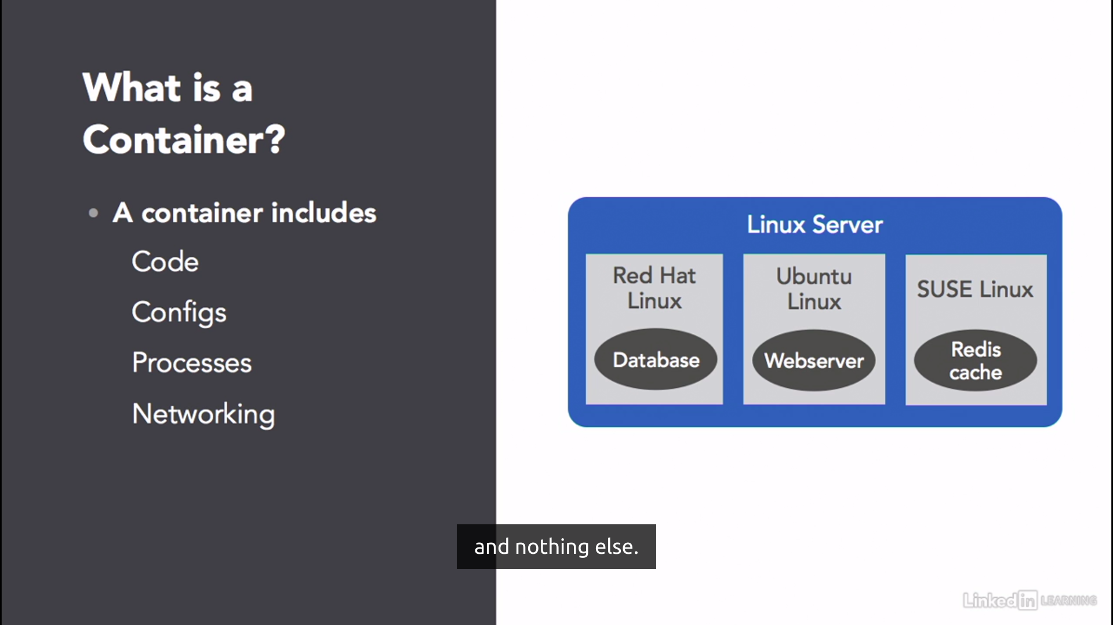

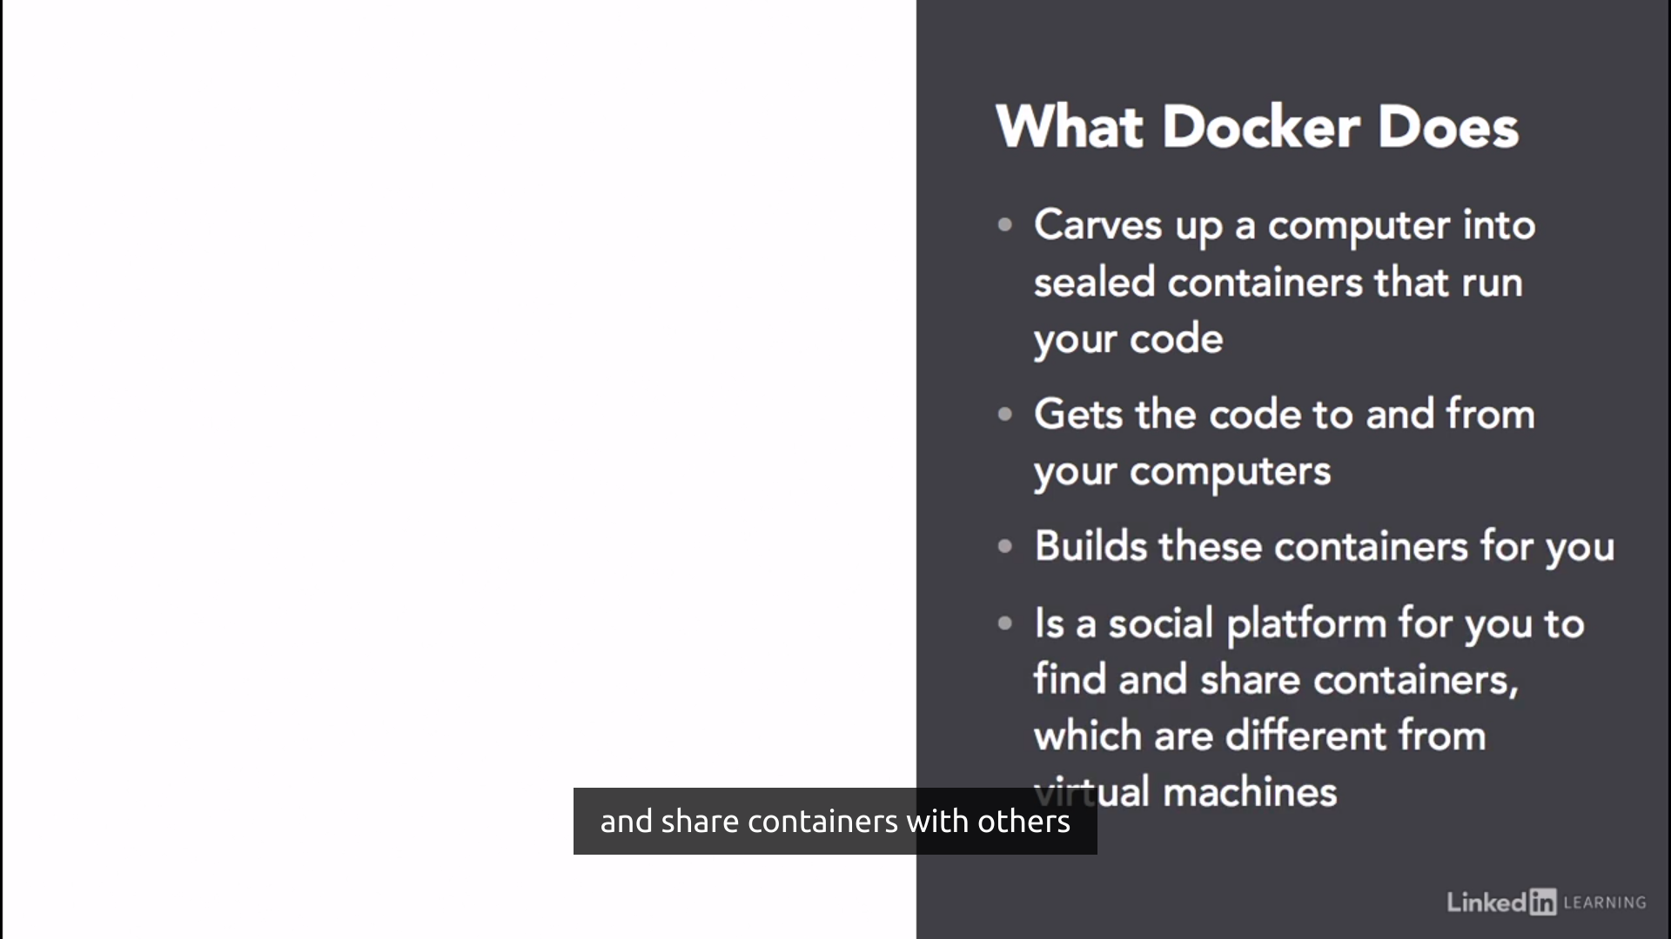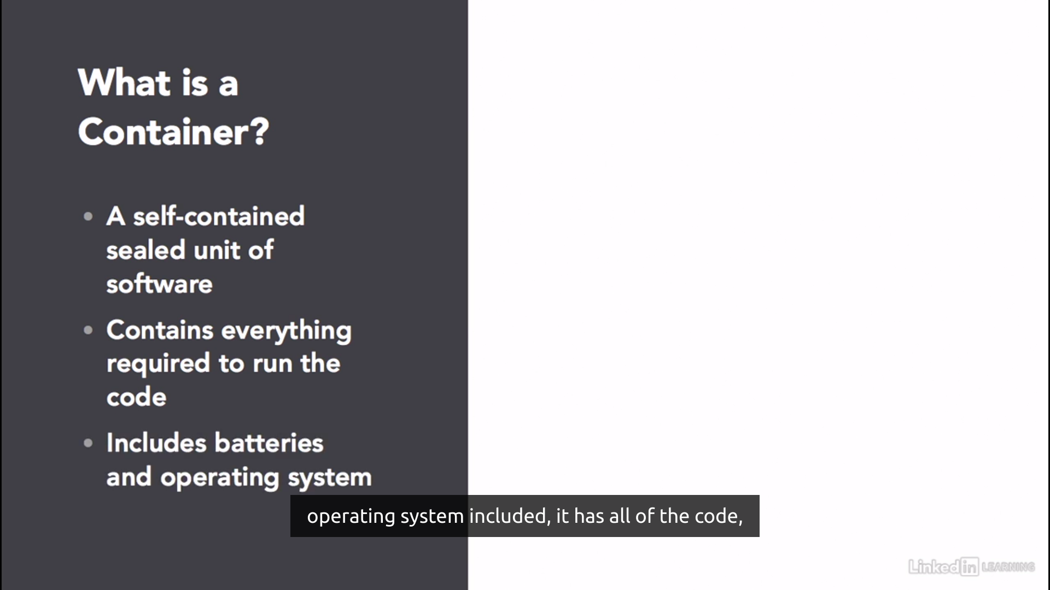

Why do we use Docker?

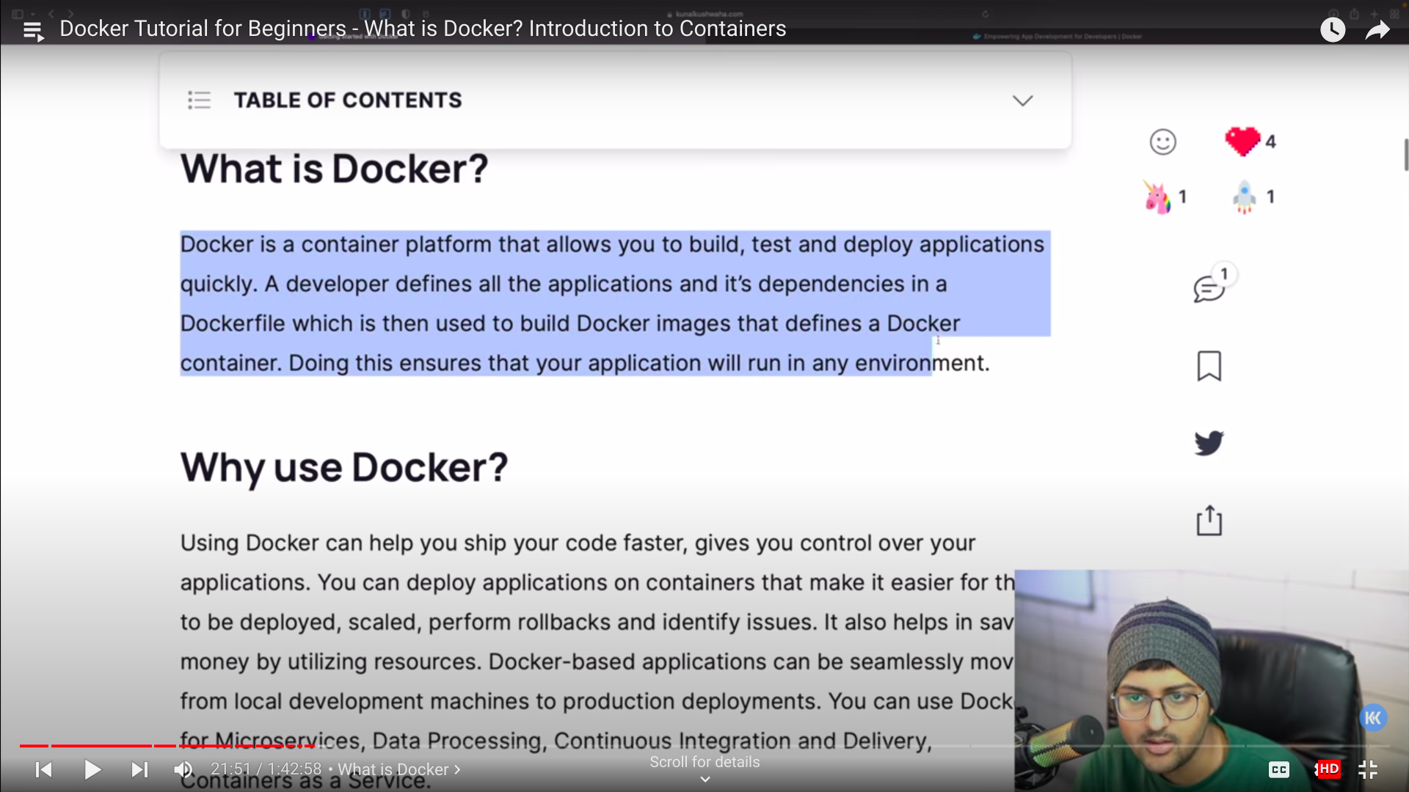

In the client side, docker build,pull or run make changes in the docker host. Which contains images and containers.

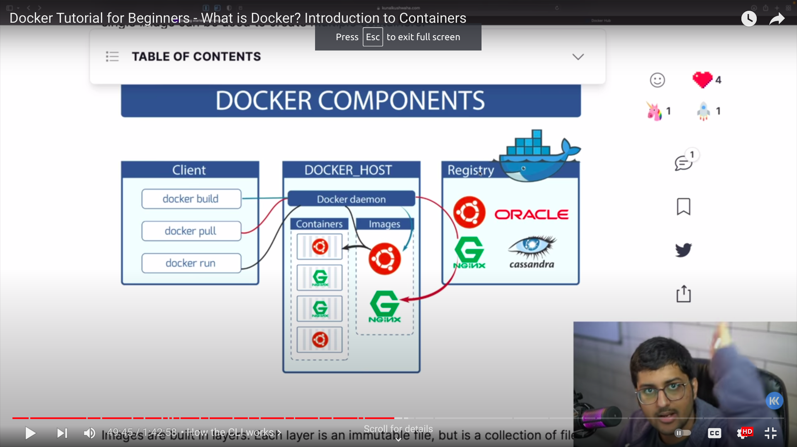

Docker ps -a– lists all containers

Docker ps -l– lists the last the container in which we worked.

Docker run -it ubuntu– It will find image ubuntu or else it will pull from dockerhub then make the image run to make changes in image.

Docker image–Shows all images which is being made.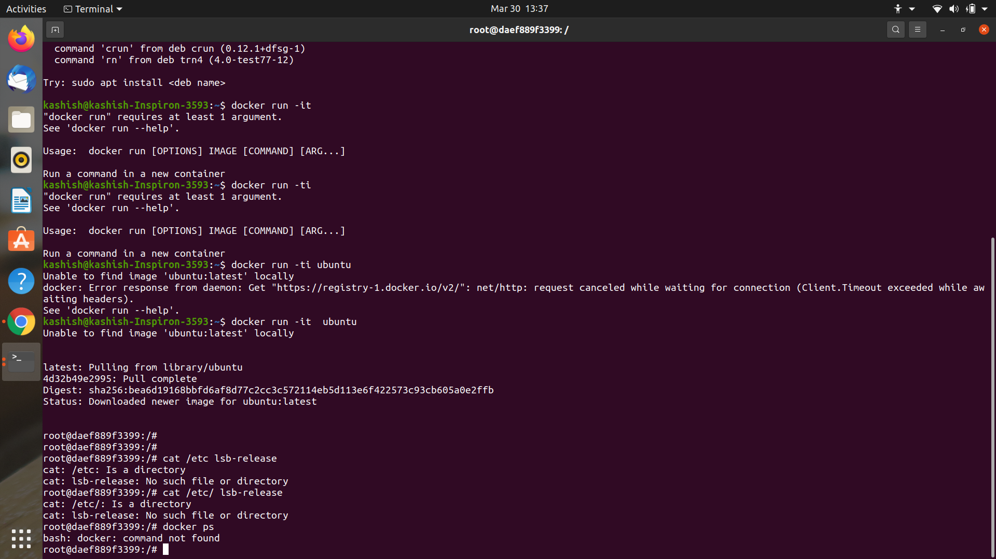

Docker ps -a– lists all containers

Docker image–Shows all images which is being made.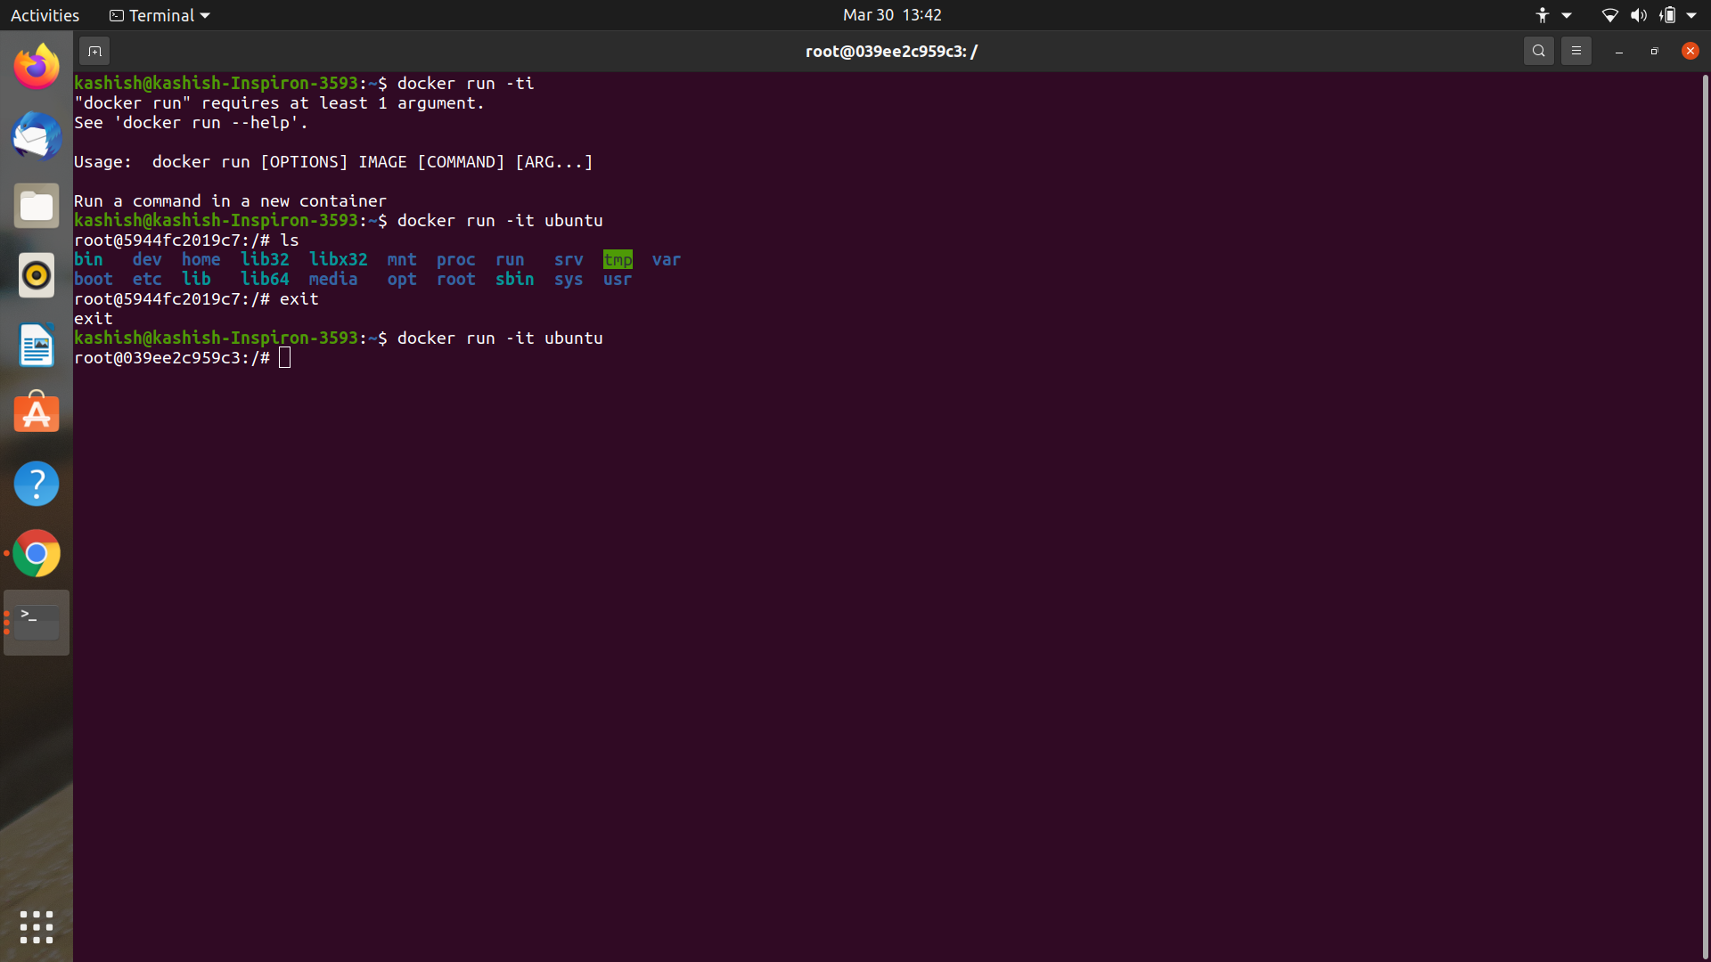

Docker Flow: The image createdis runned by docker in docker container and container get stopped andthen it commits and forms new image.

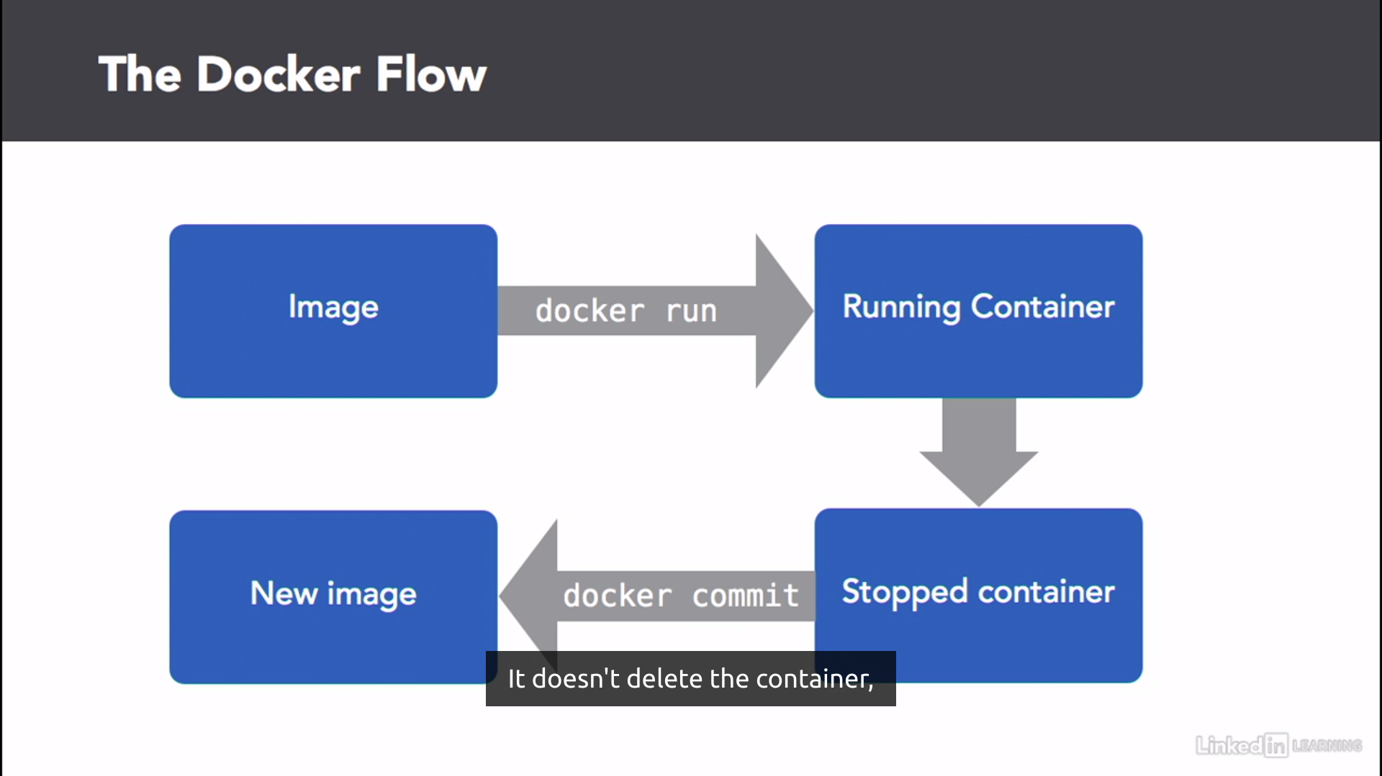

It shows that the name have been changed of the repository while it commits image ubuntu.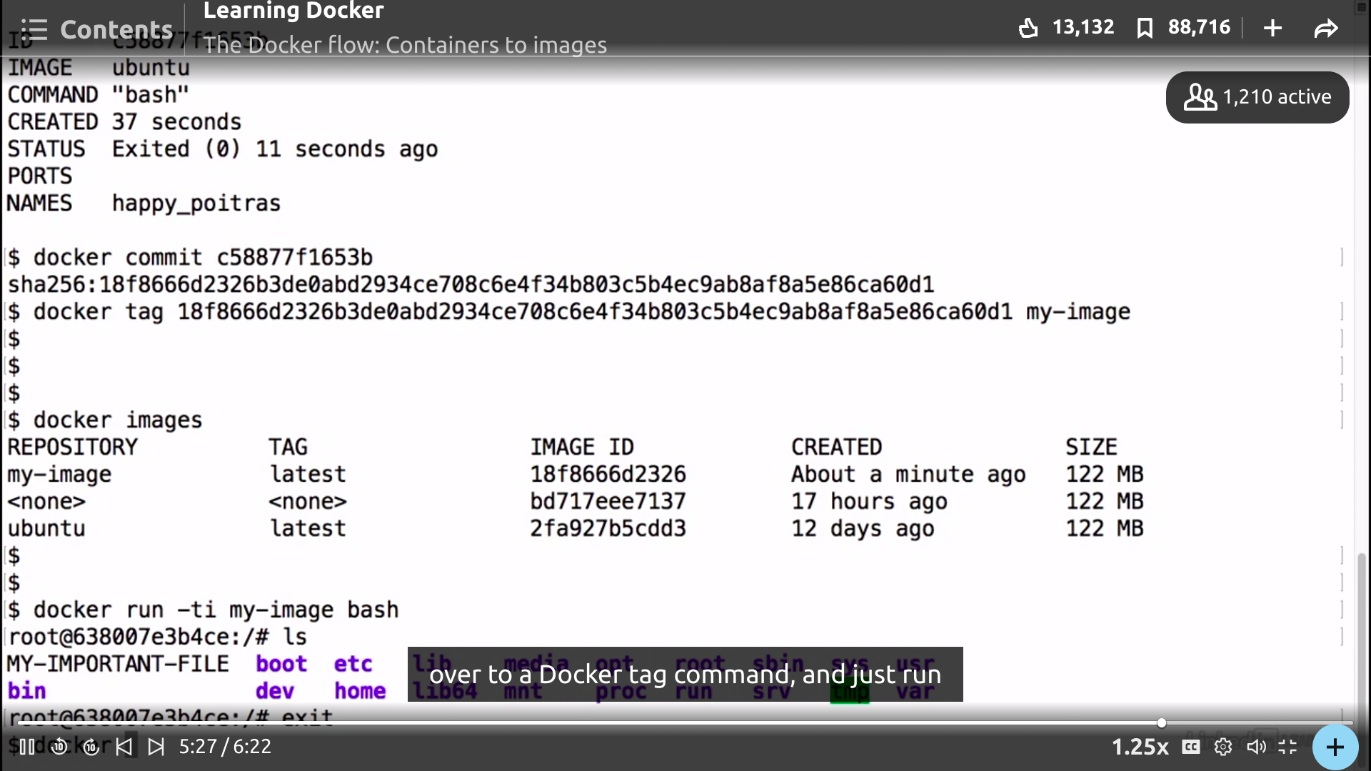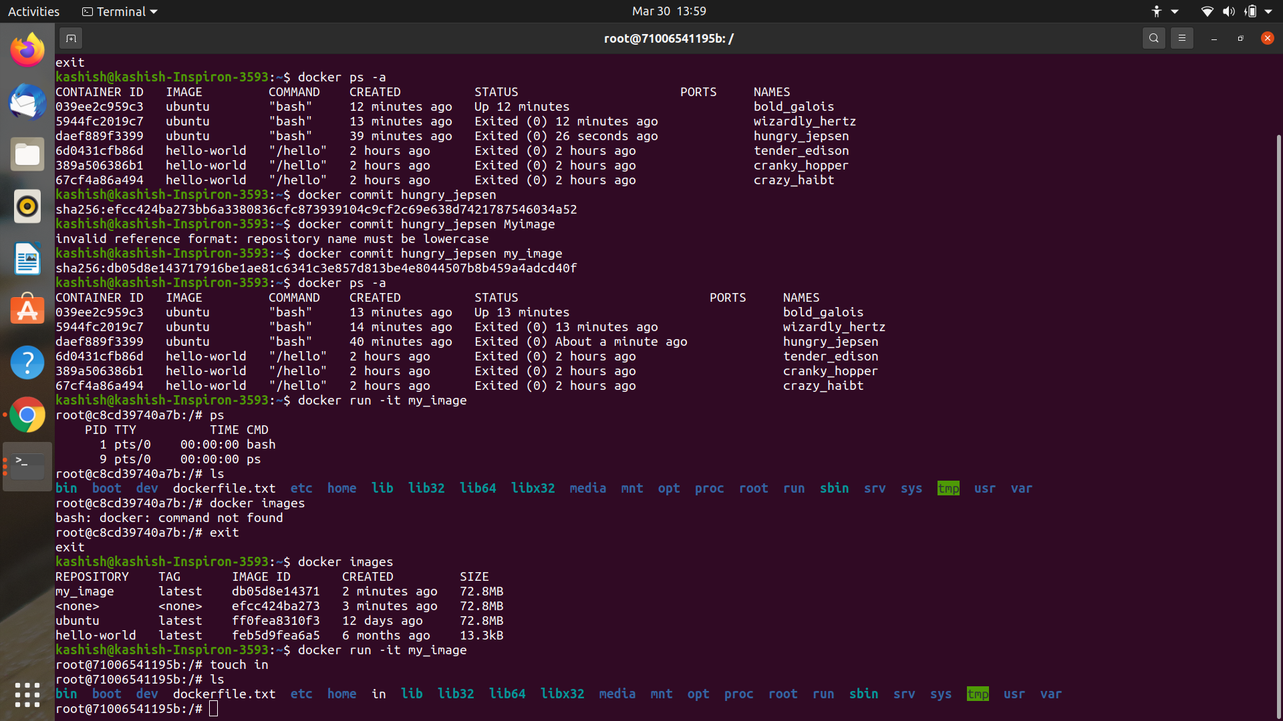

-d→It shows the image is running in detached mode.

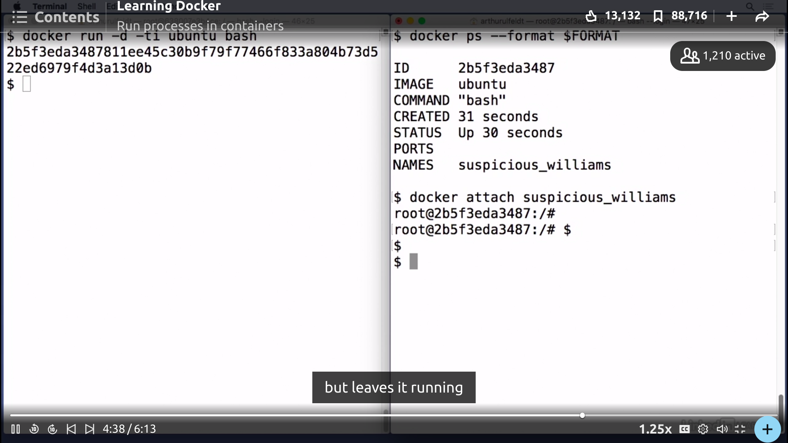

Docker exec -ti <image-name>-->It runs a new command in running container.

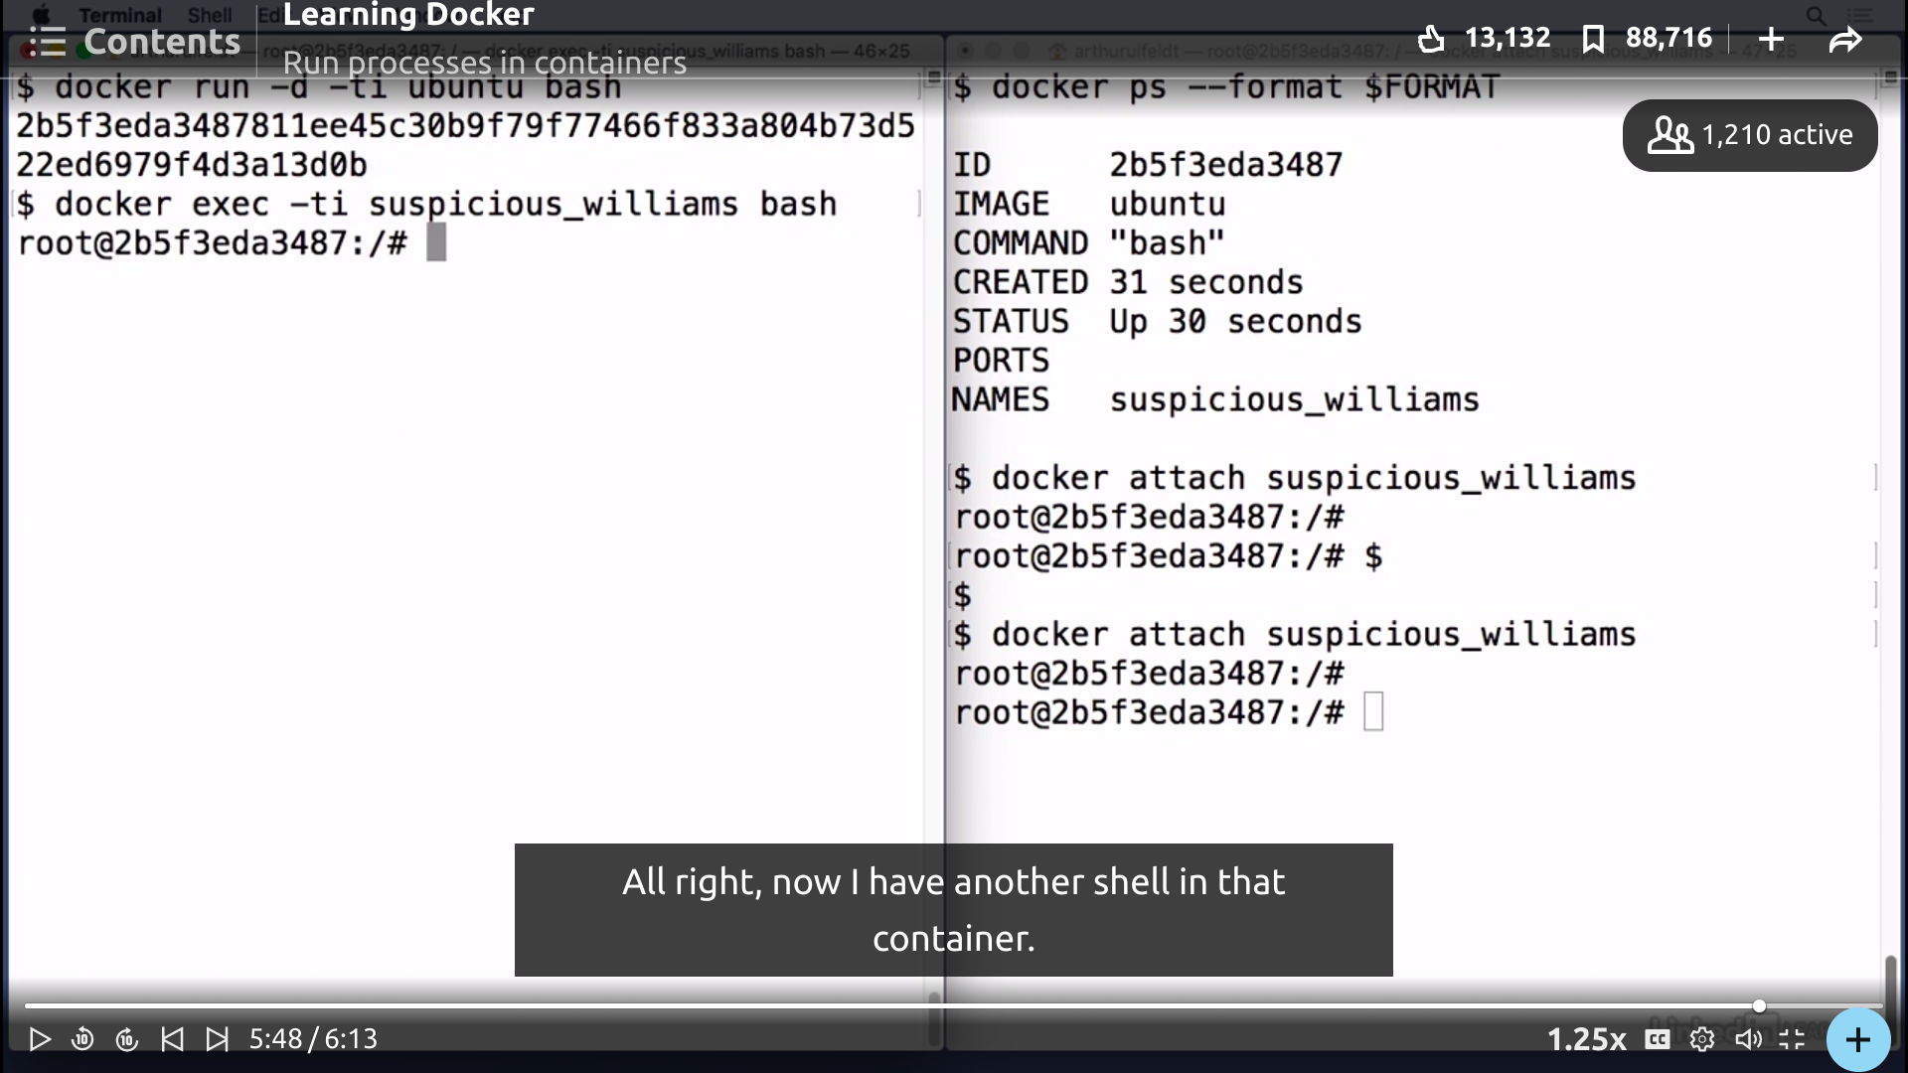

Docker Logs:: shows the information of the container.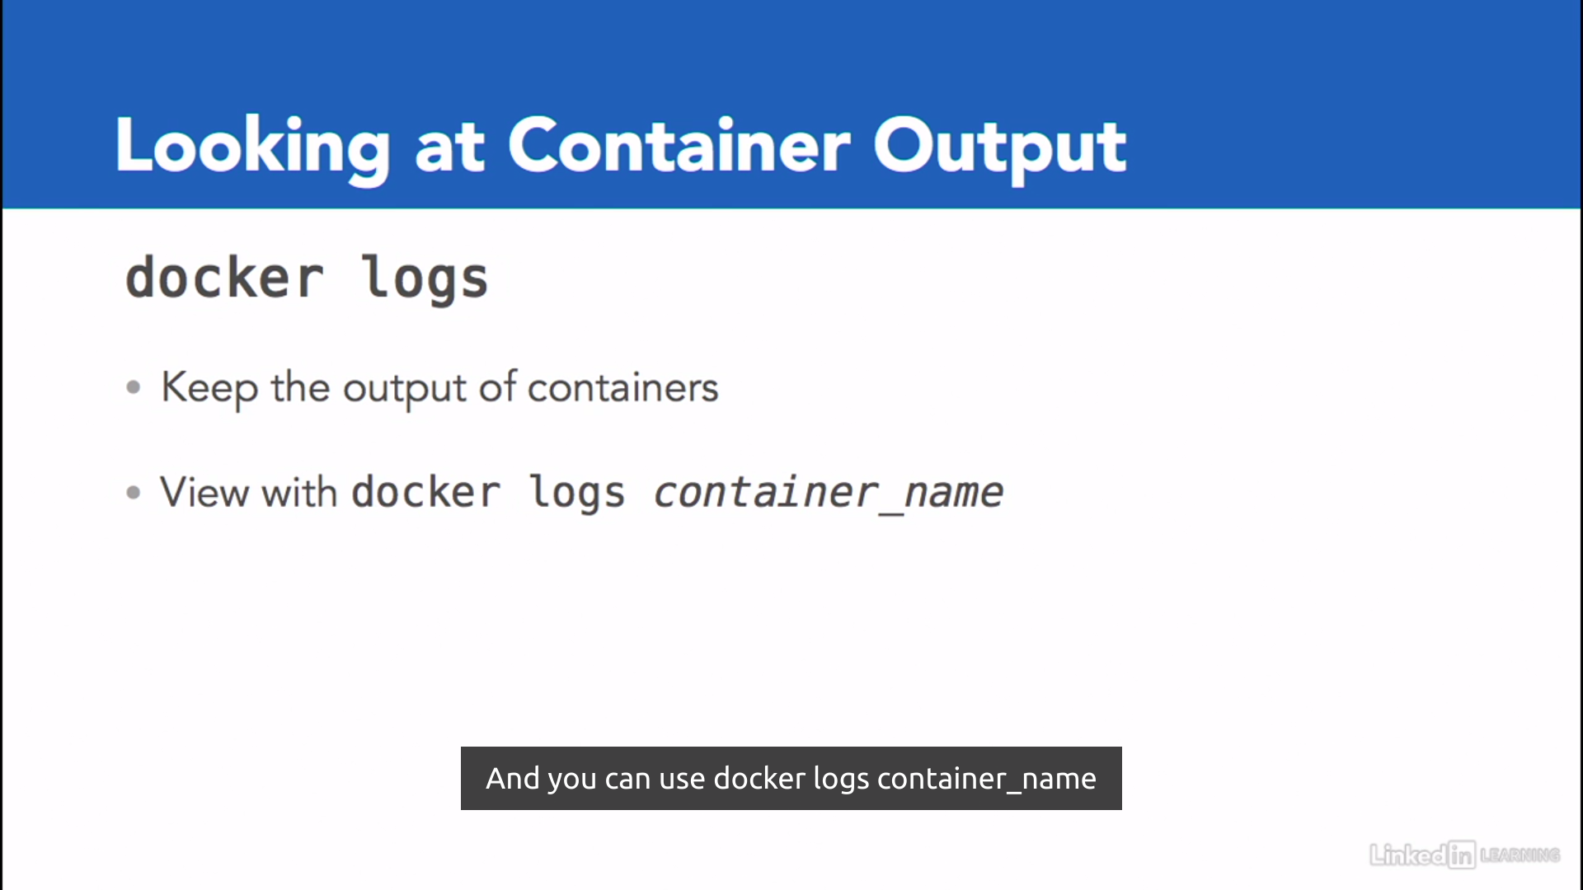

For stopping and removing the Containers→ following commands are used.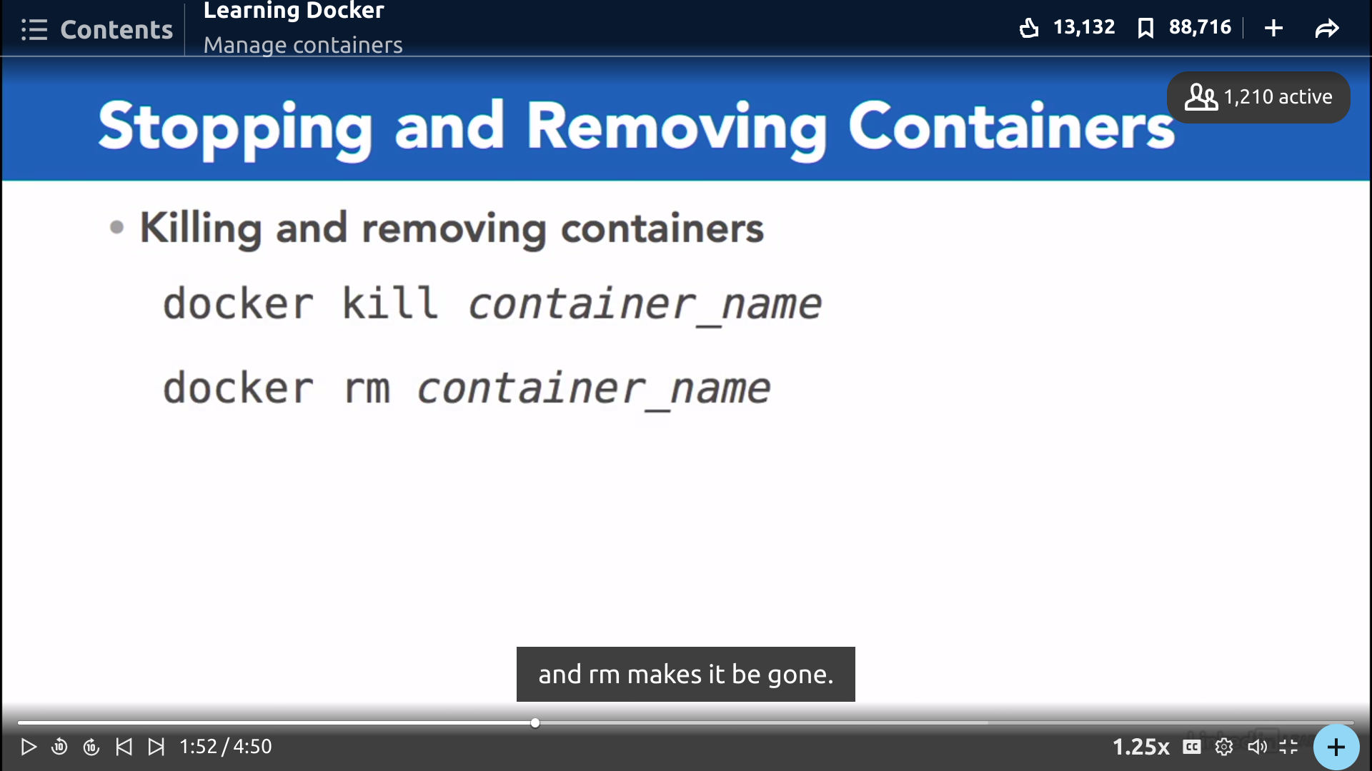

**Container networking:**

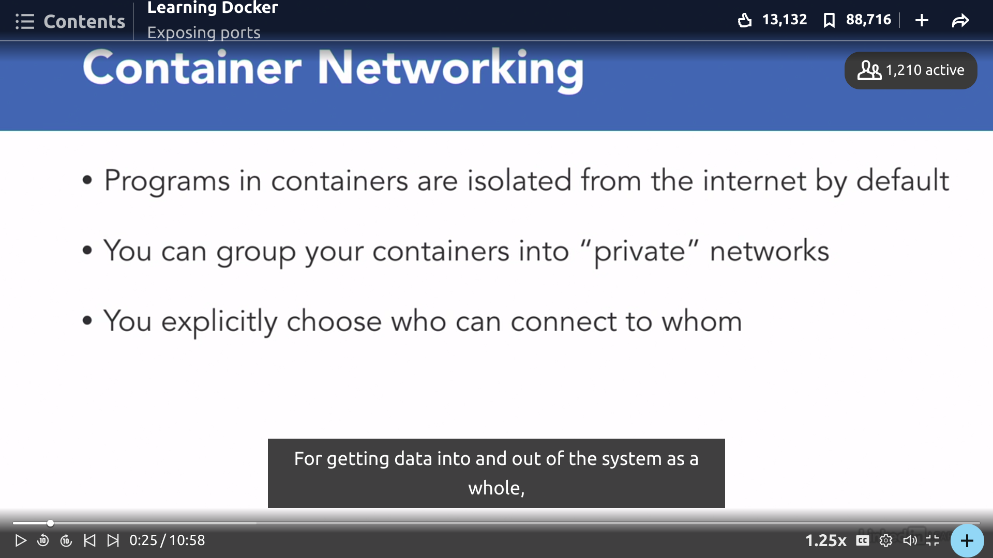

-p connects the container to the host.

Localhost portnumber:Application port number.

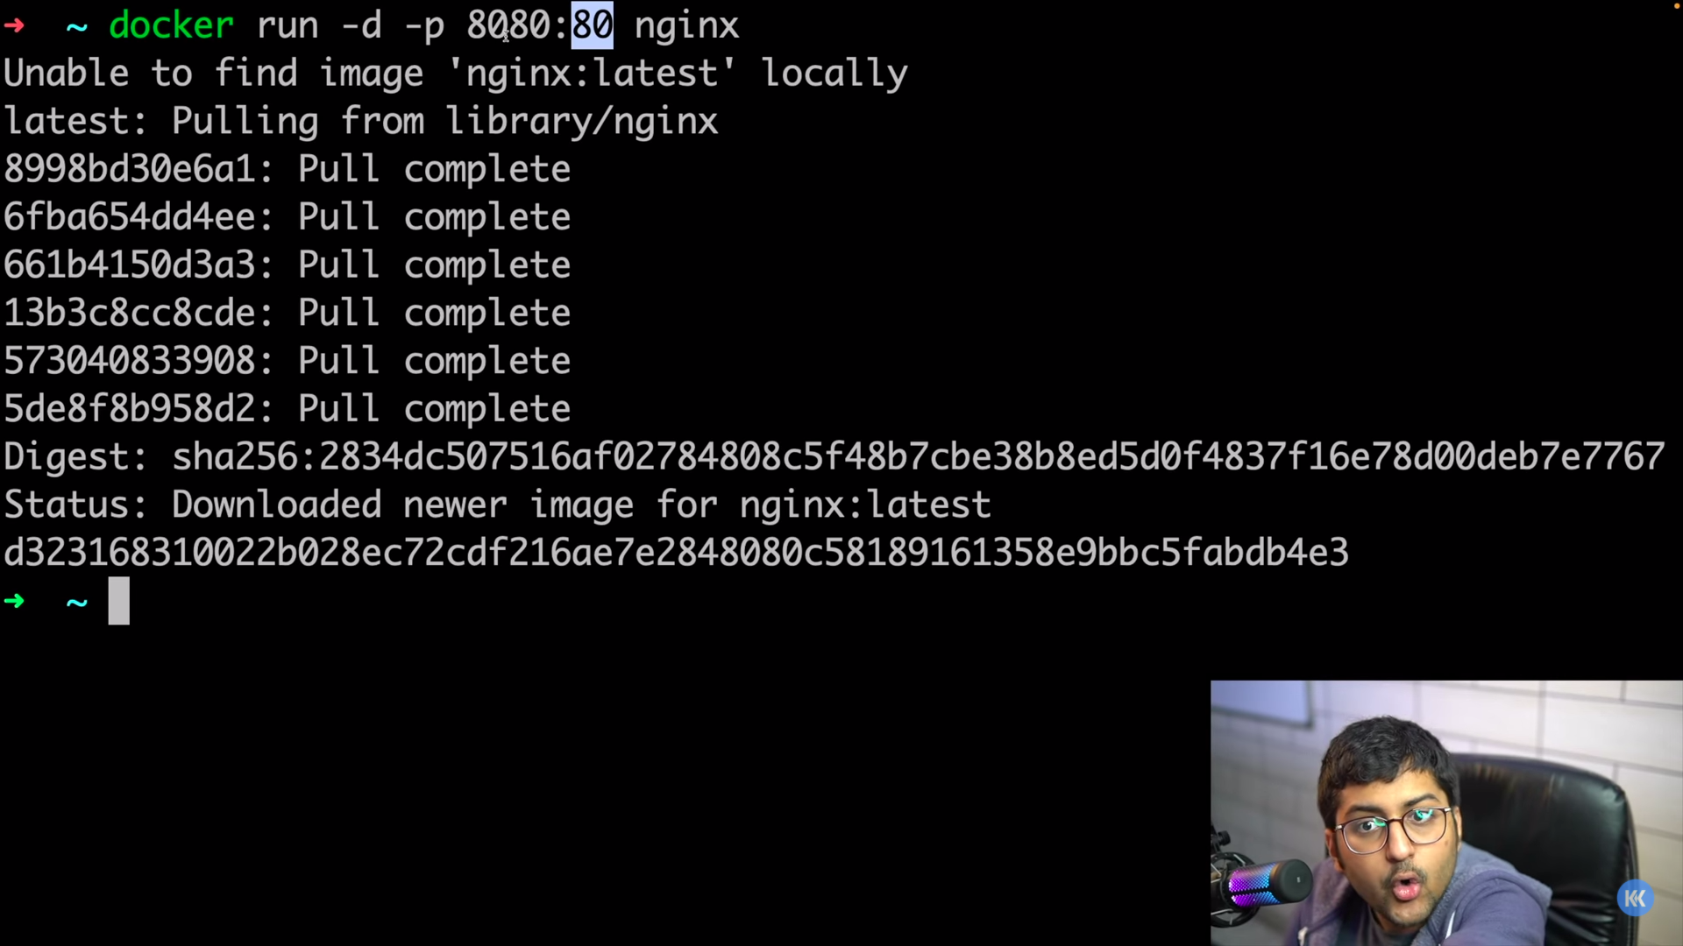

Exposing Ports Dynamically: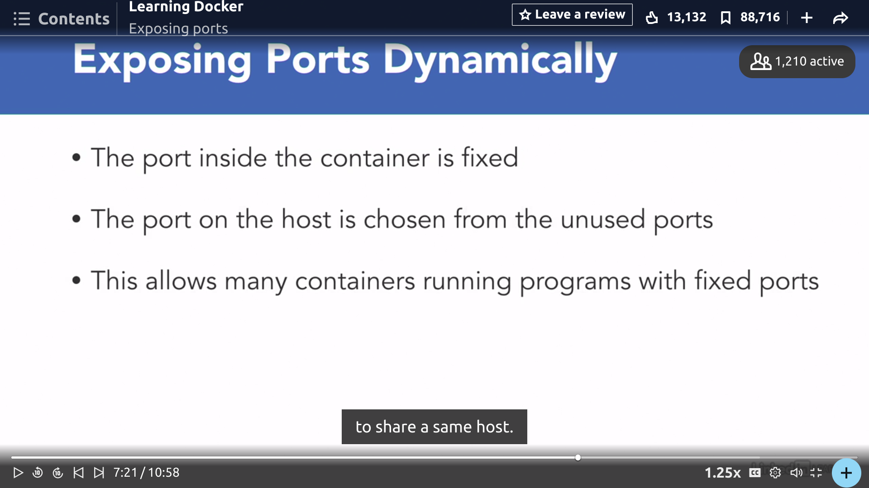

LocalHost port should be different to use when connecting withe container as if container can have same port numbers.

There’s host where all Containers are situated.

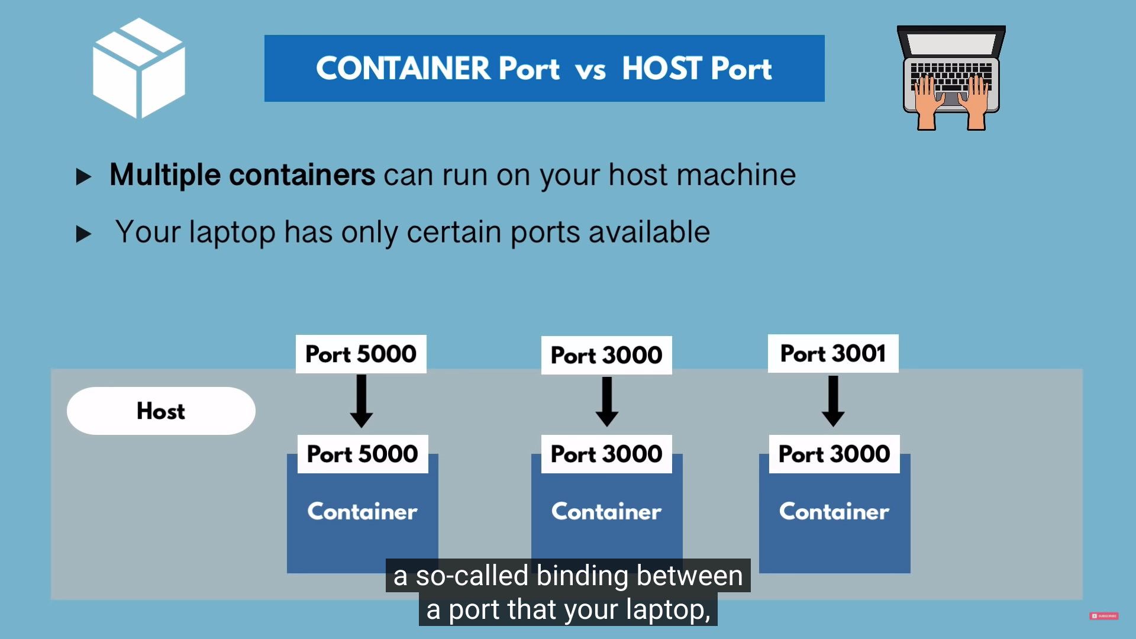

For connecting with the local computer we use port numbers to connect.

Docker run -p 6000:6379 redis

6379 is the port number of the application (here redis).

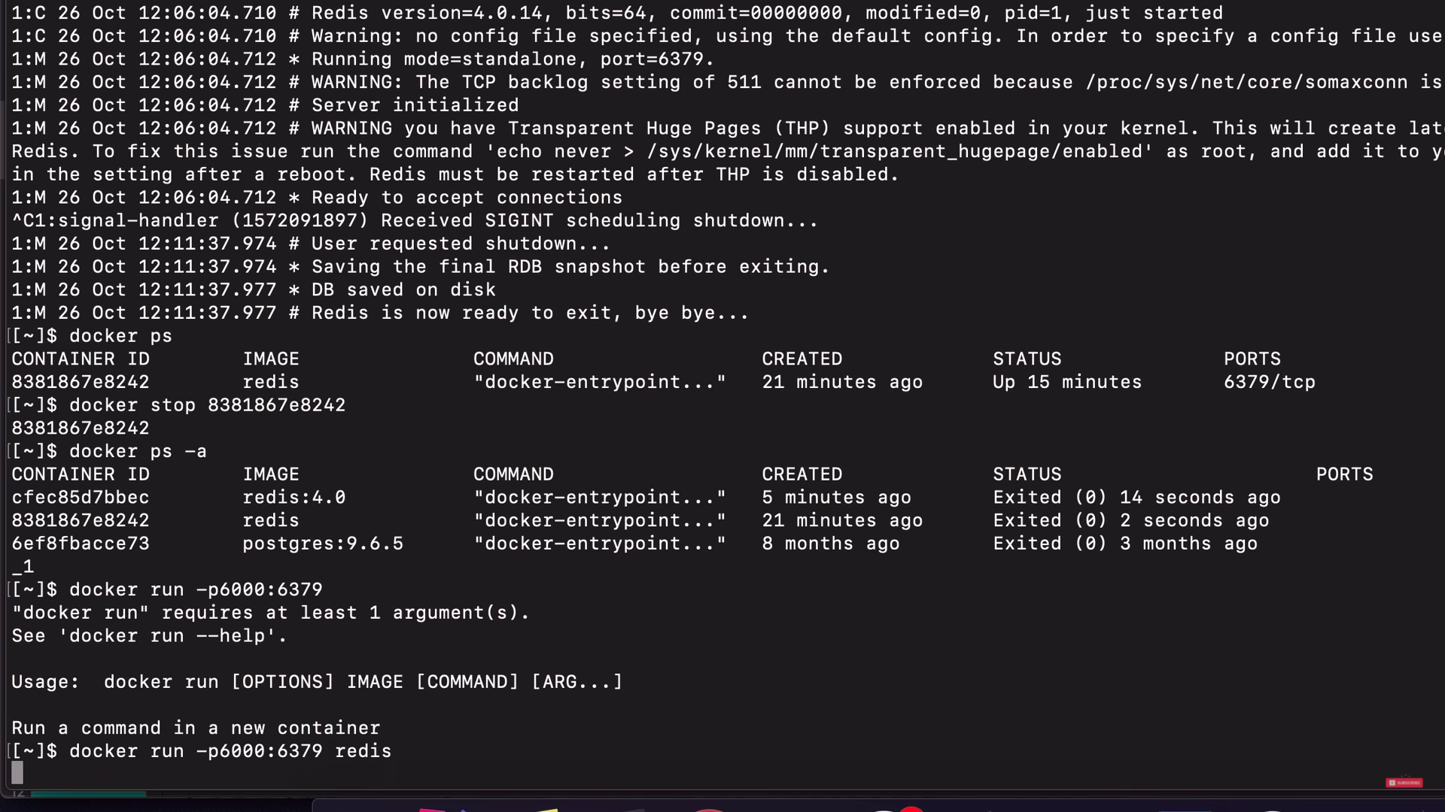

Here we connected the containers with locally.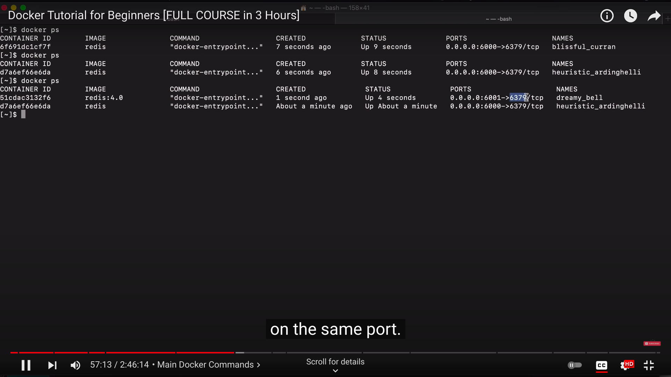

Here it gives the name of the images and recreate it by –name .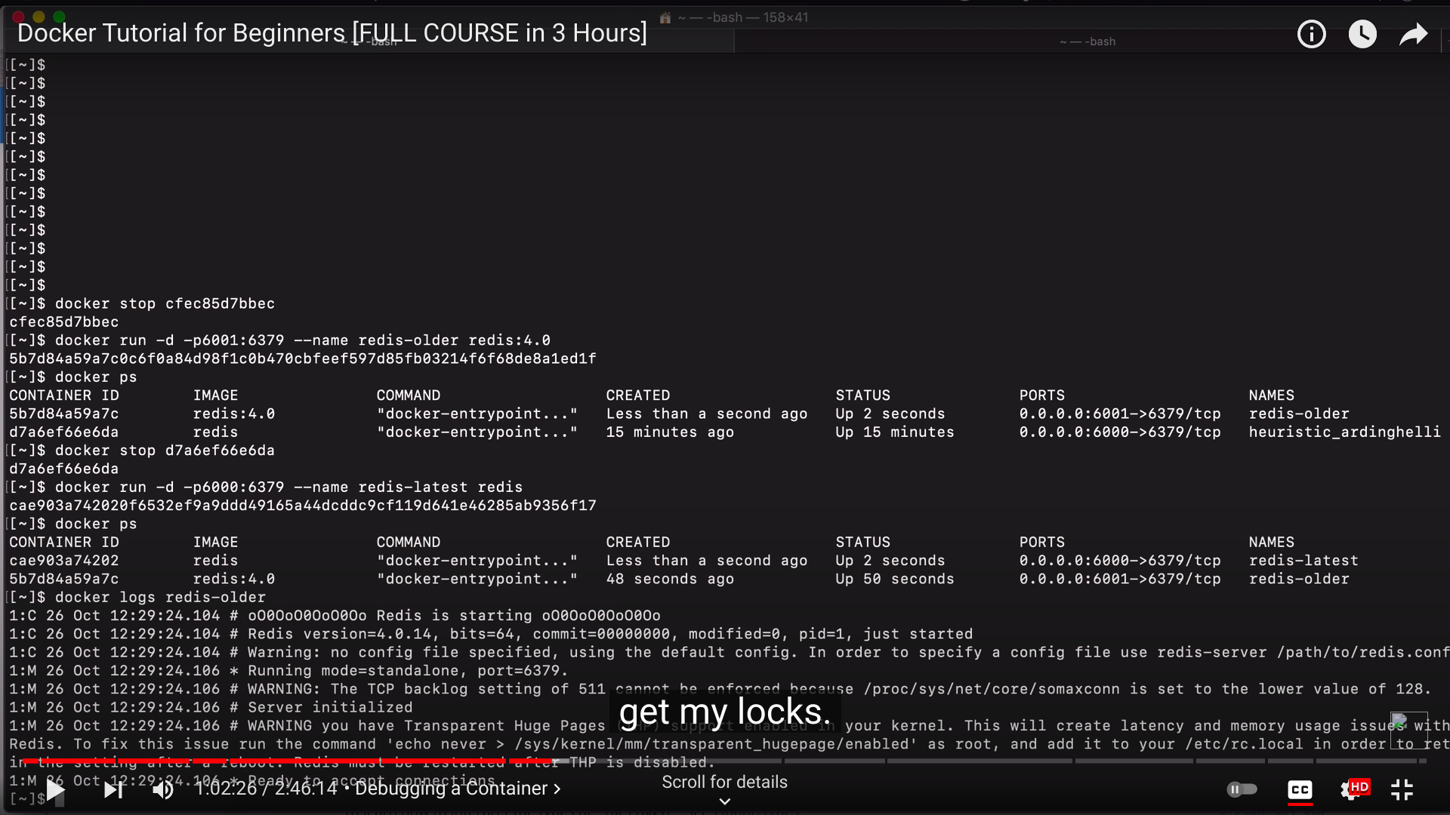

By not installing Mongodb or mongo express ,we can use it by running in docker and connect it with application.

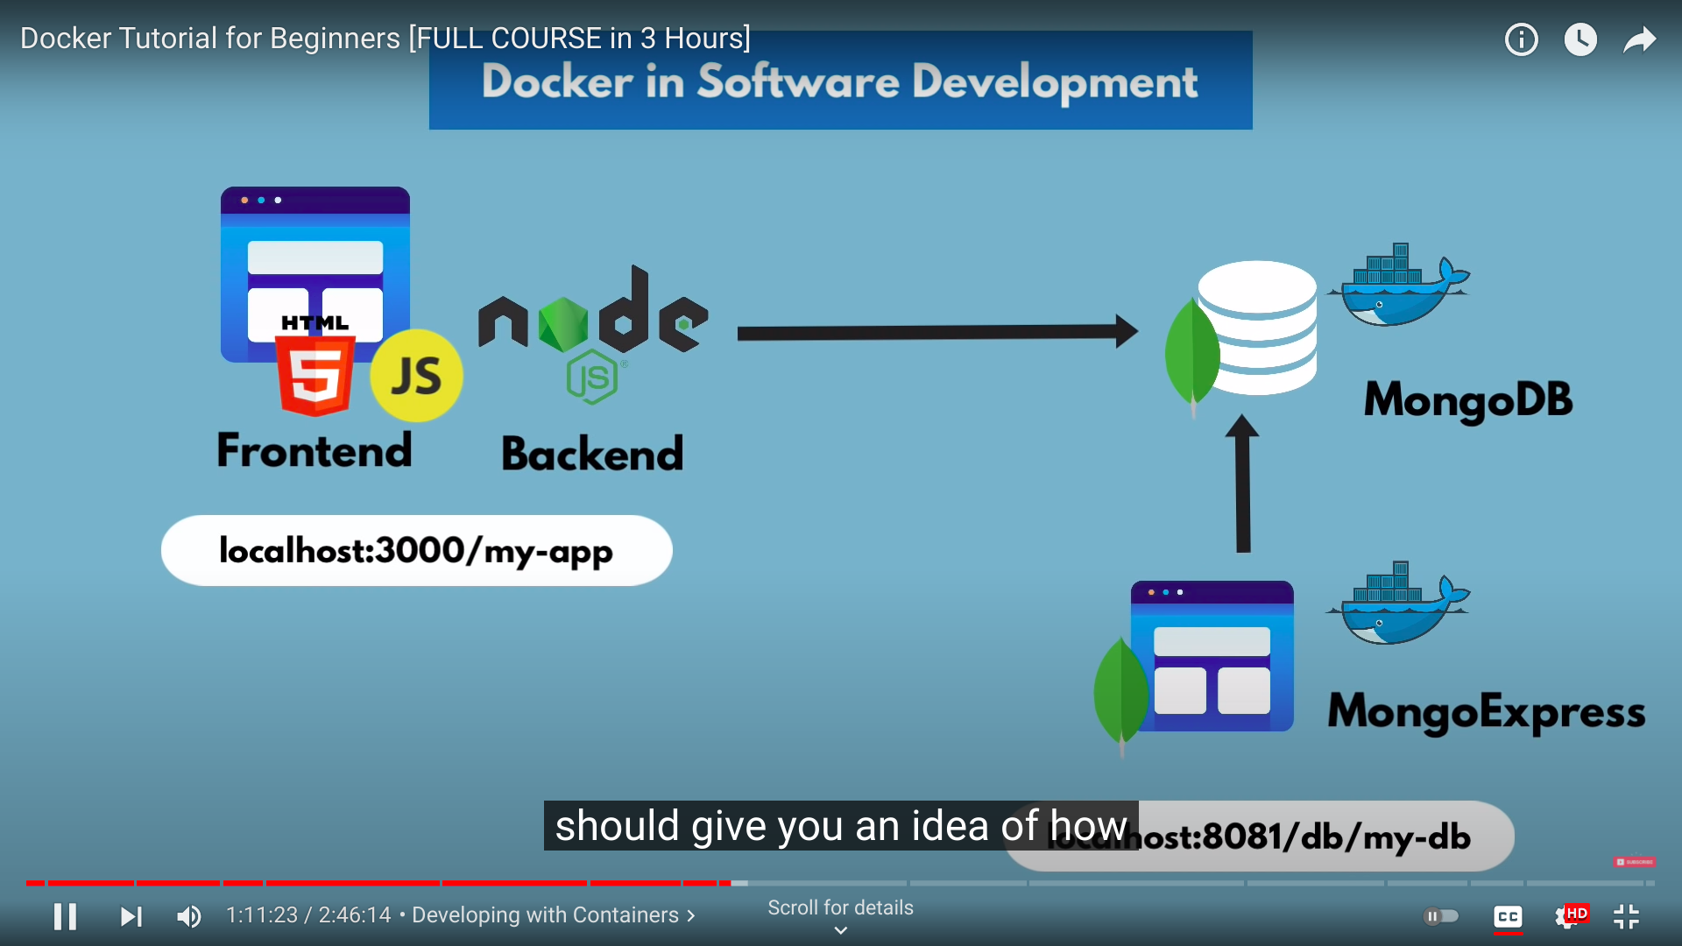

The isolated Docker Network contains the 2 containers which is being connected to each other as well as the whole docker network is been connected by localhost.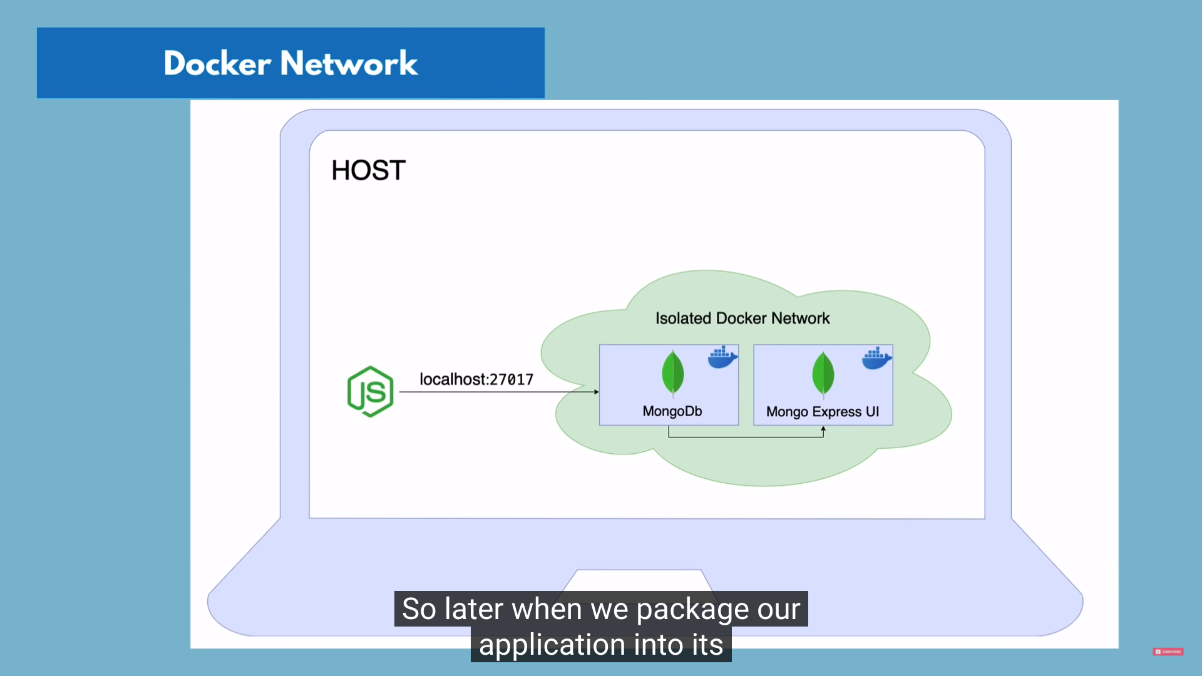

Using pull command for using mongo and mongo express images inside docker container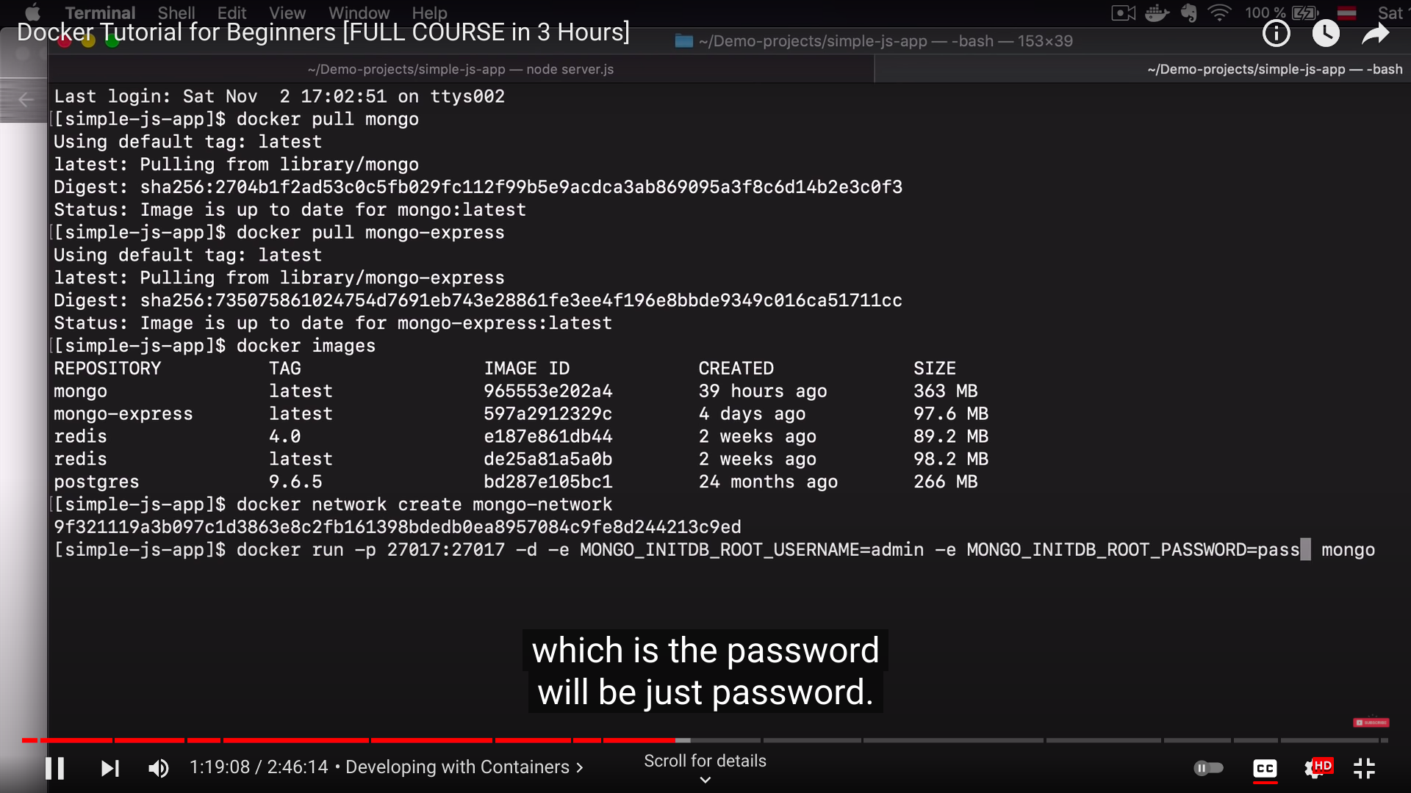

To create network we use docker network create mongo-network.

And for showing ll networks we use docker network ls.

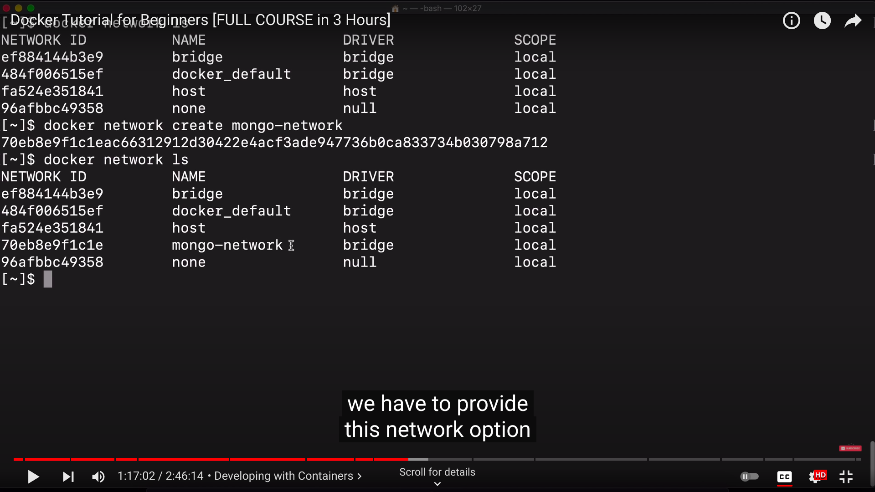

To create instance of mongodb and for authentication to use mongodb.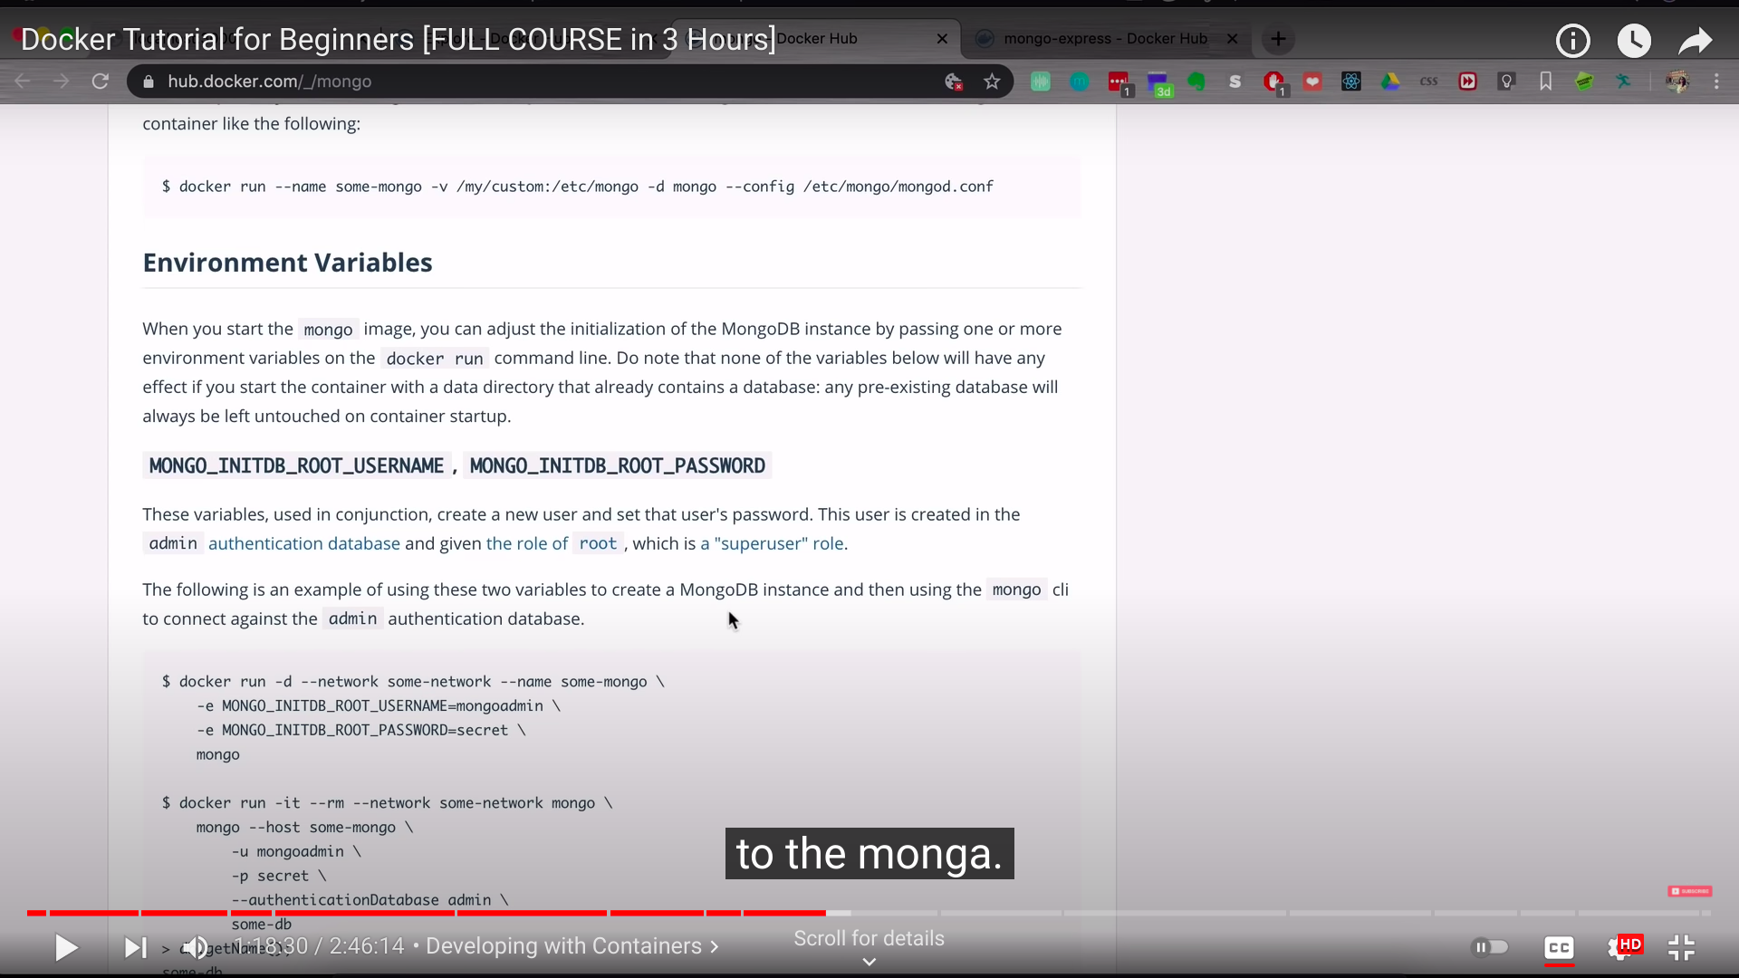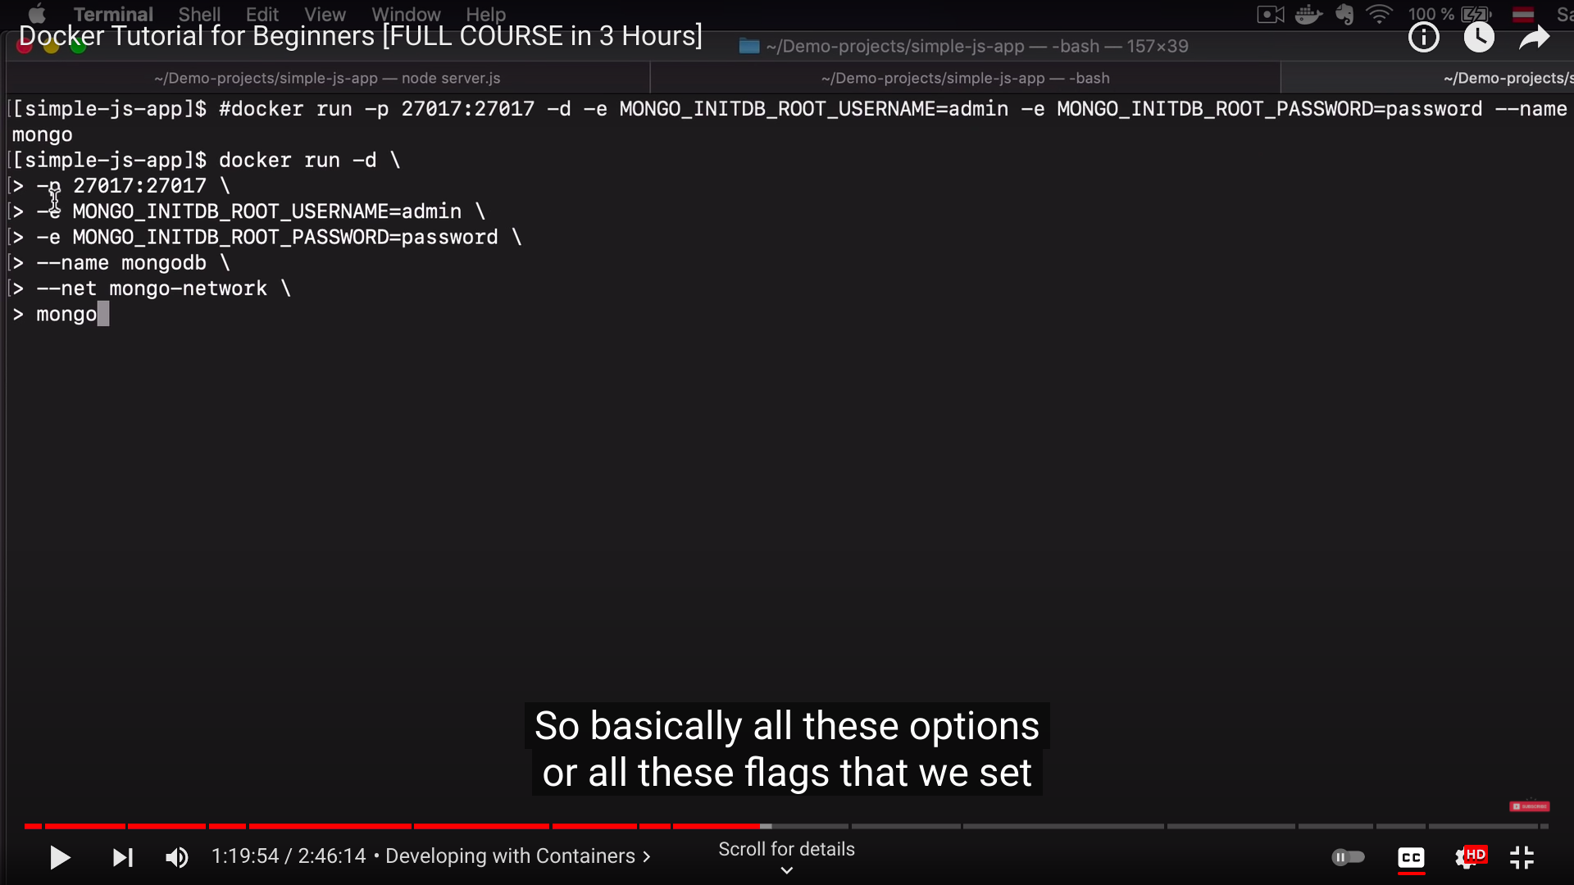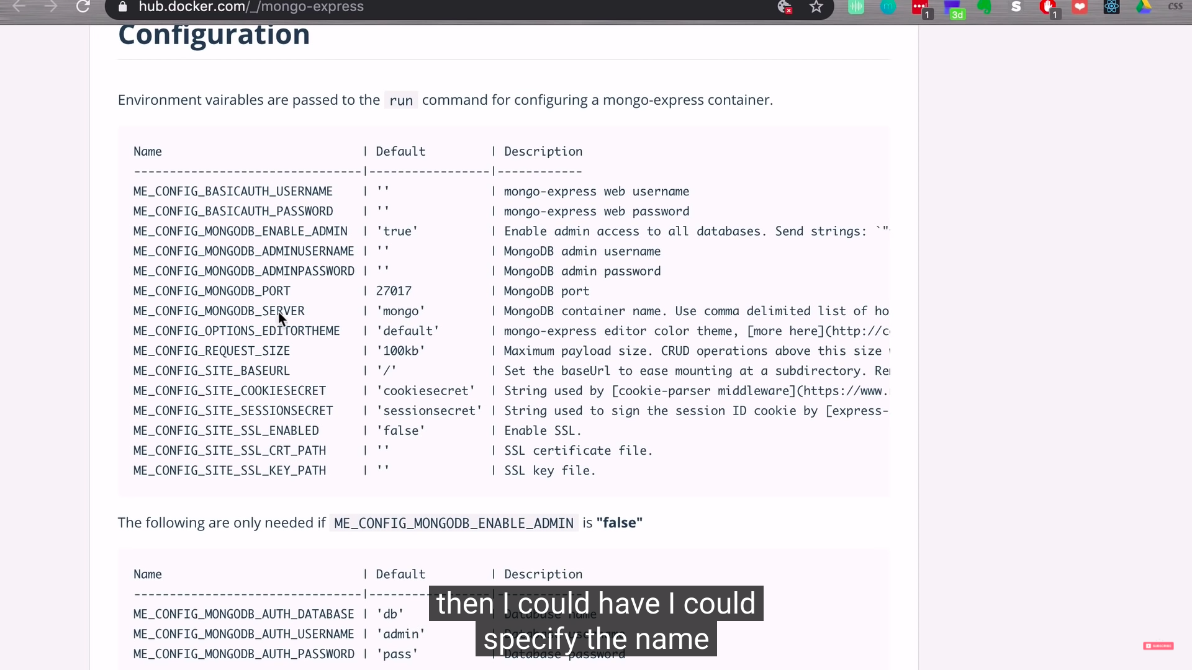

In terminal,We use to declare the long declaration for networking but instead we can use docker compose for arranged format more specifications and easy formatted way.

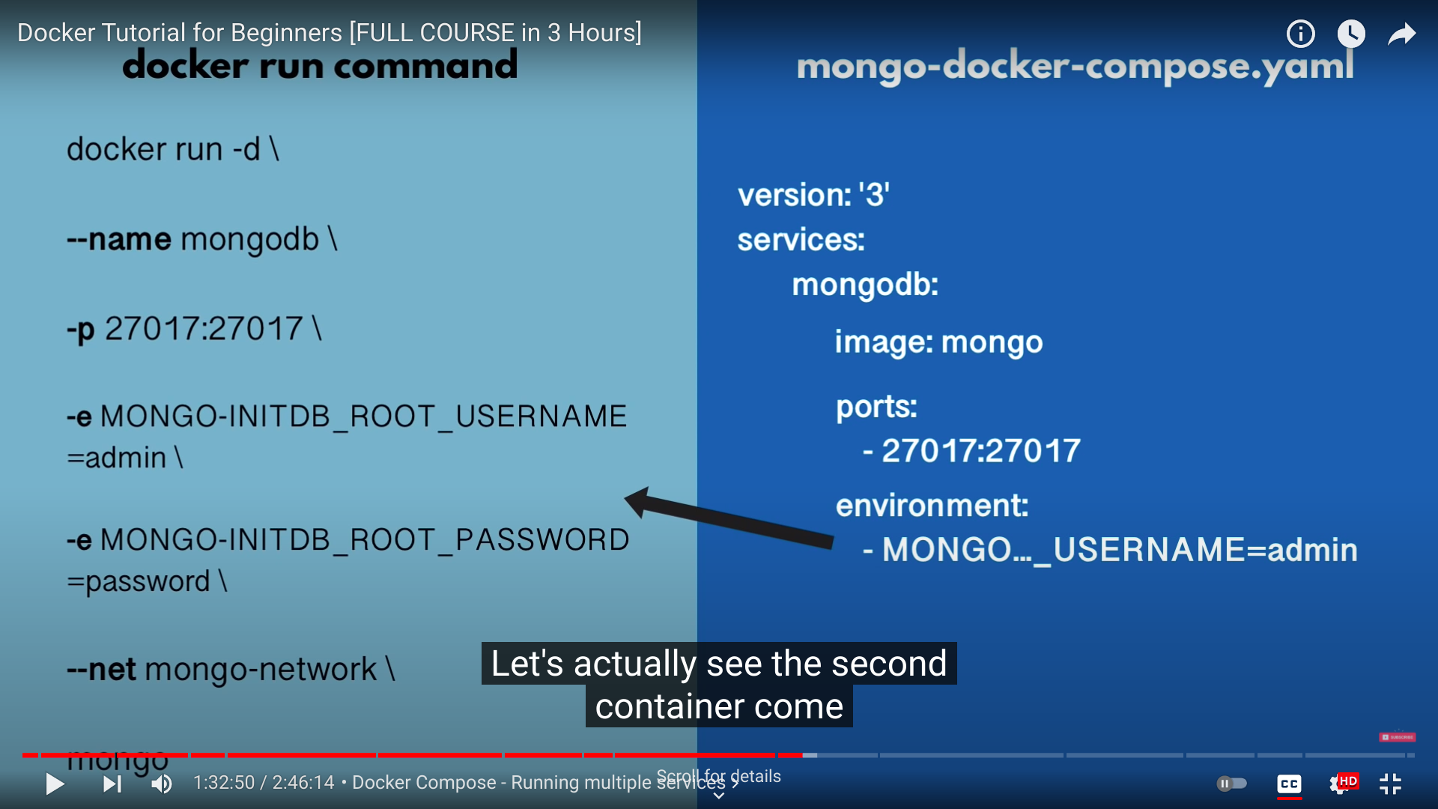

Docker Compose file for mongo express.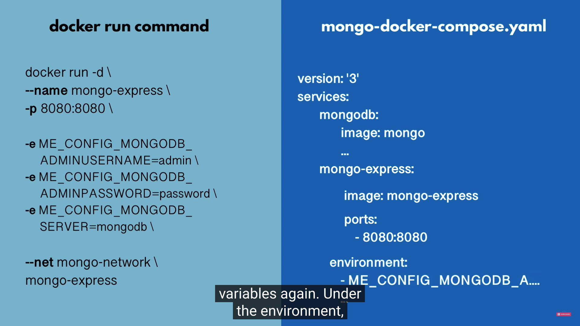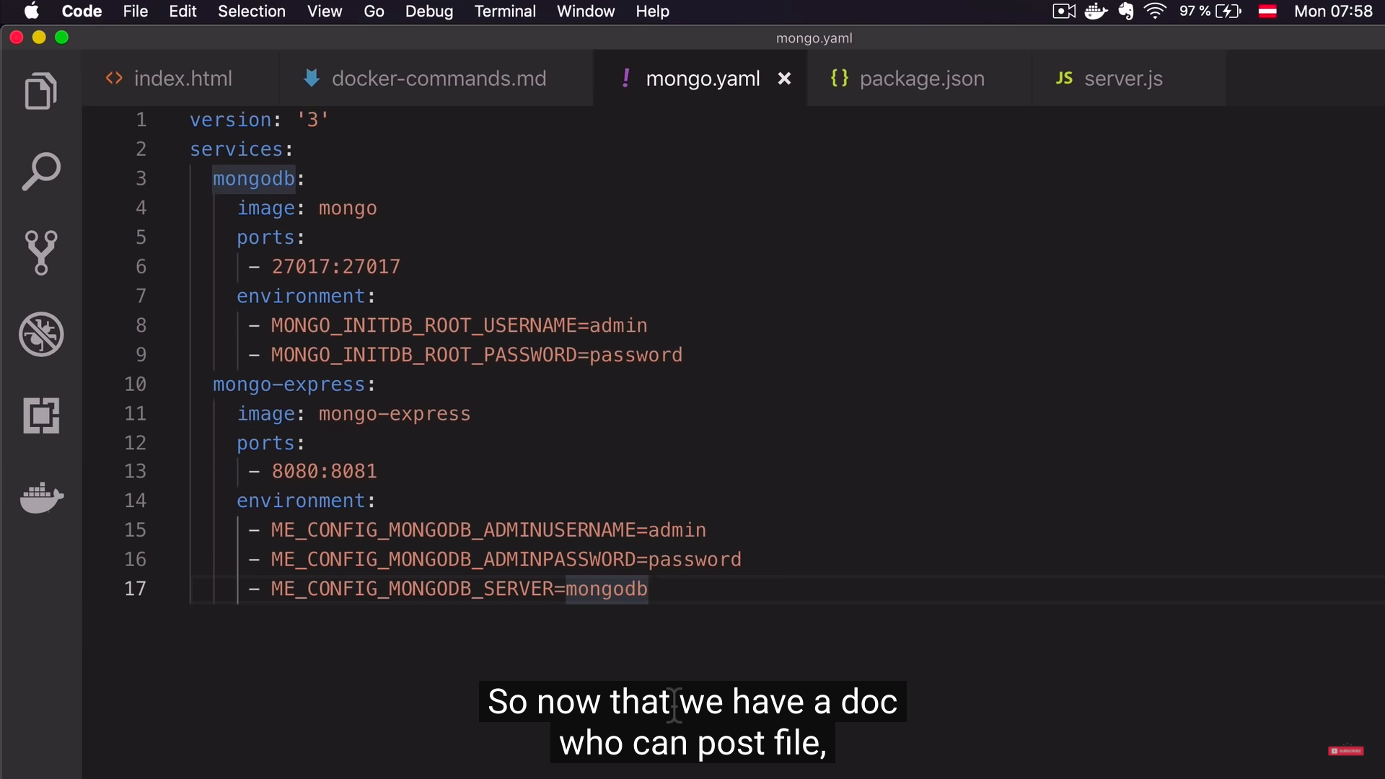

Docker-compose -f mongo.yaml up→>> Creates Network.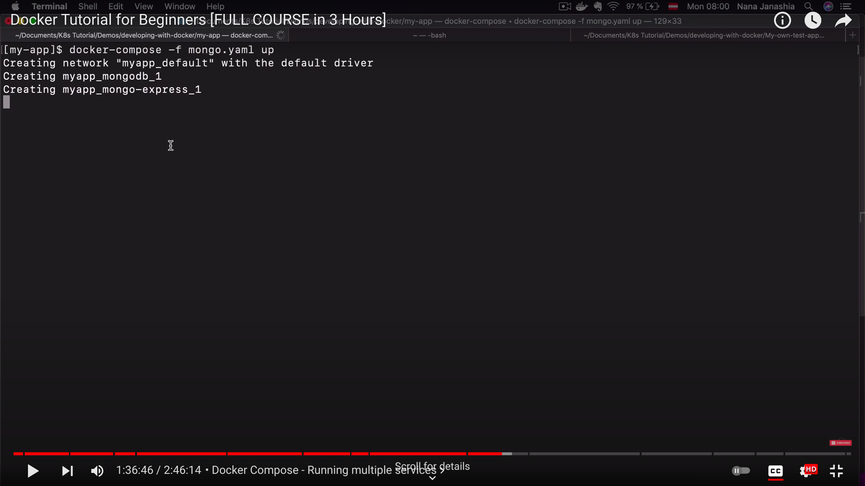

Docker-compose -f mongo.yaml down→>> Stops Network.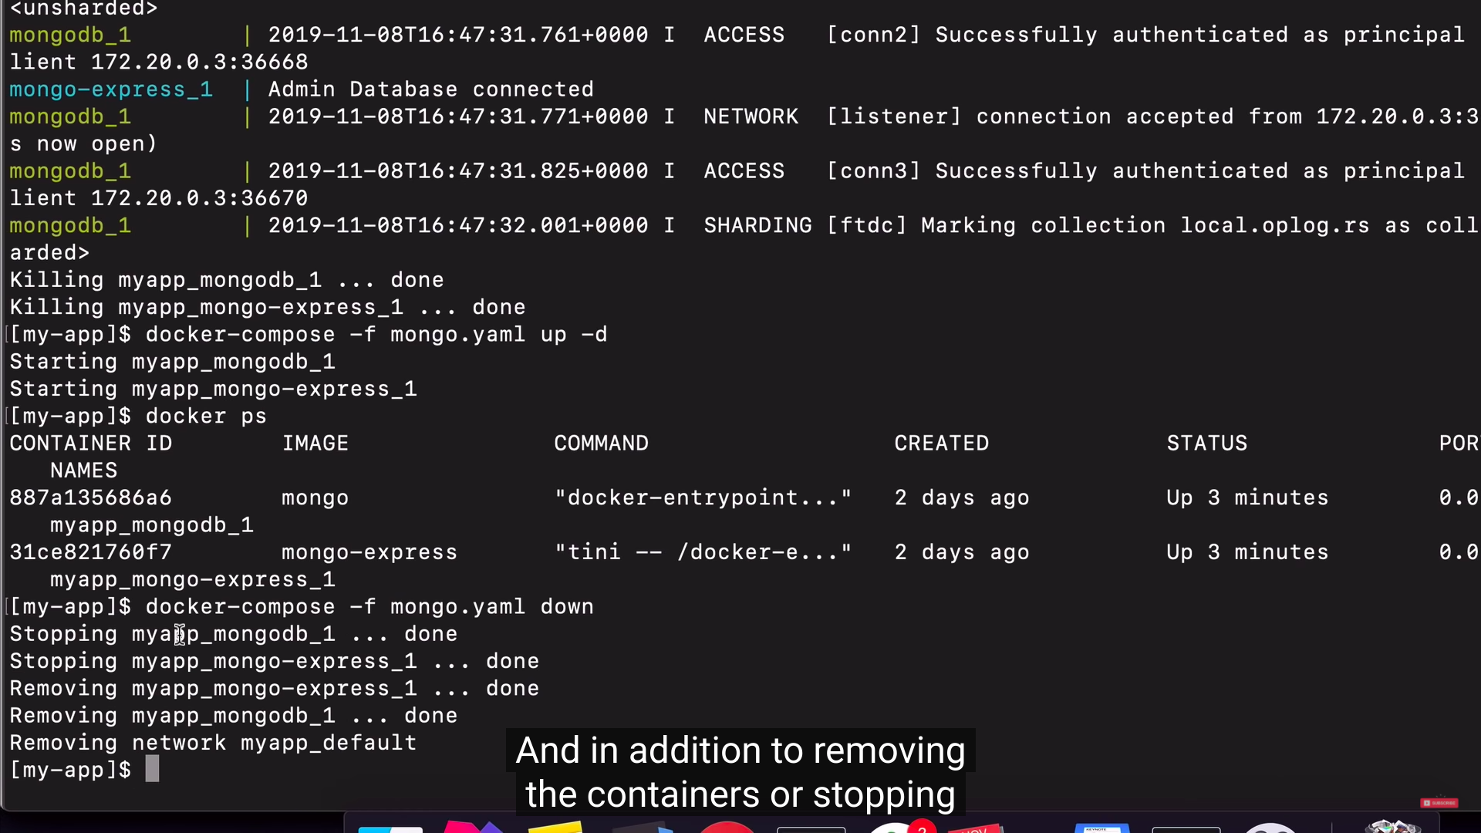

Images pulled from docker hub by logging in .

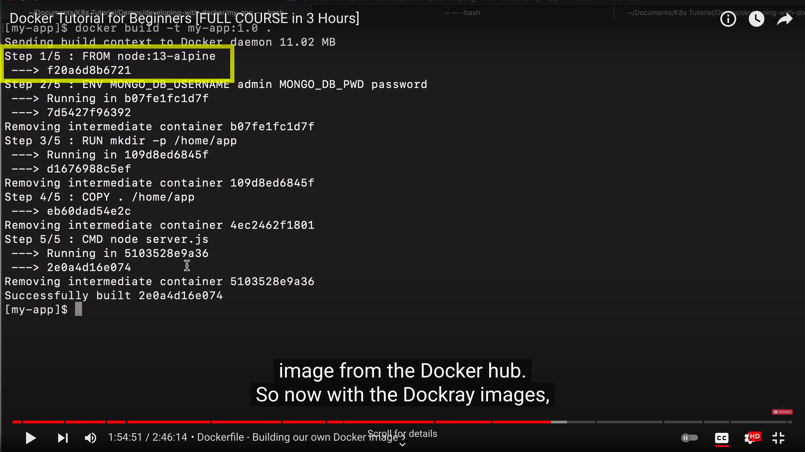

**What is a dockerfile?**

A Dockerfile is a text document that **contains all the commands a user could call on the command line to assemble an image**.

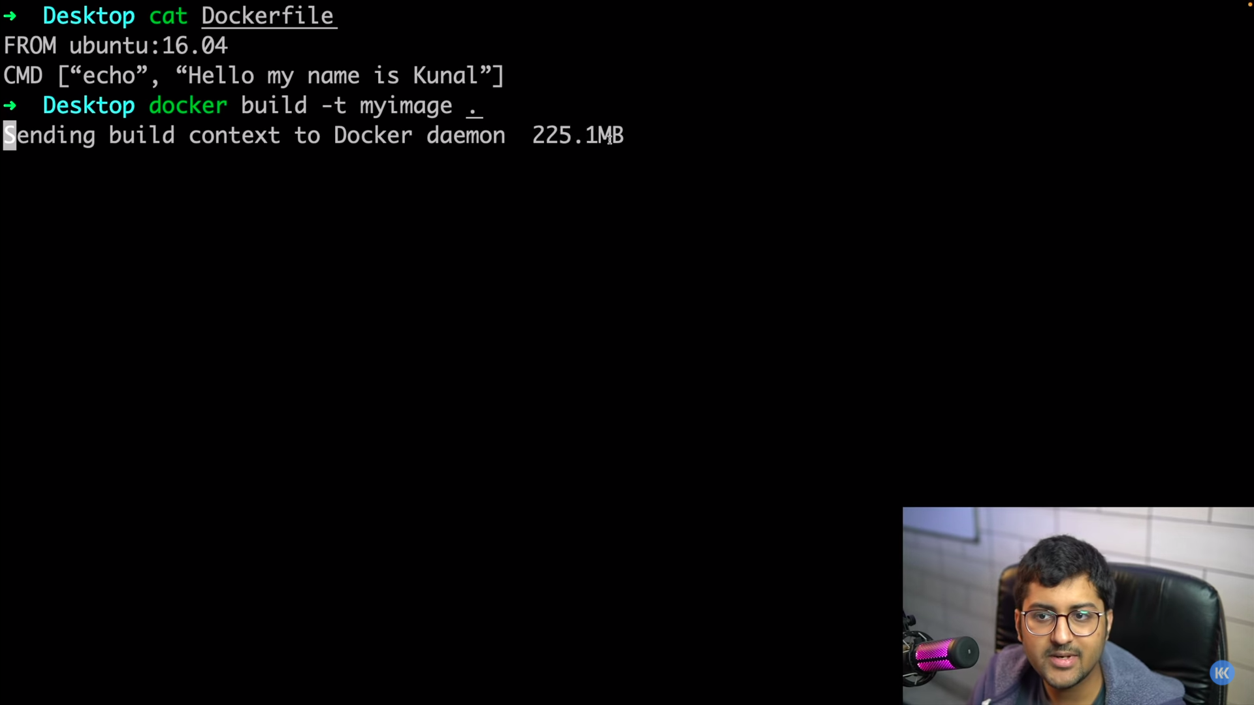

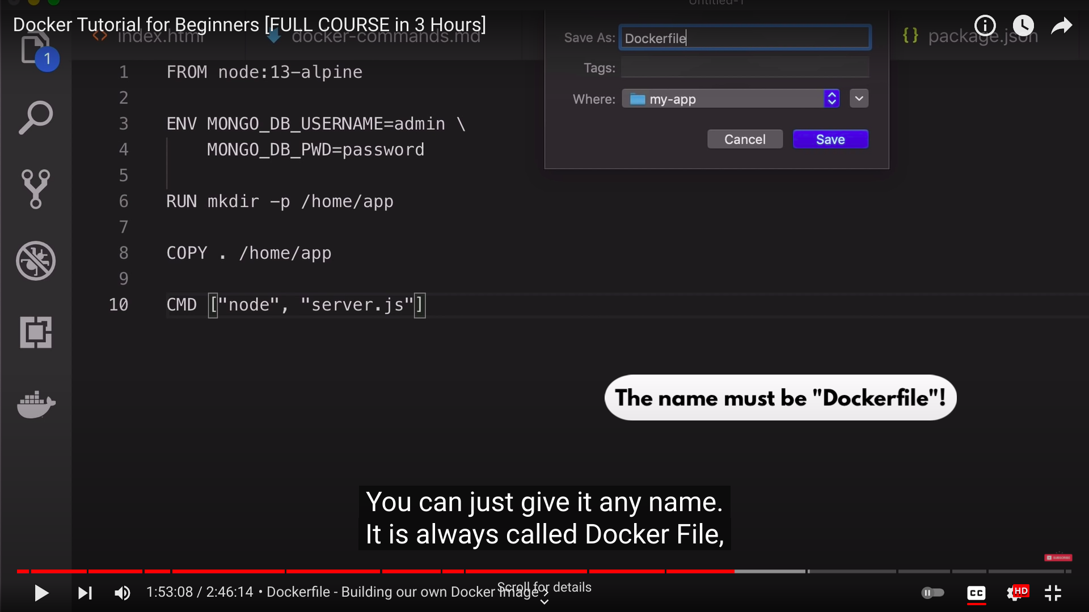

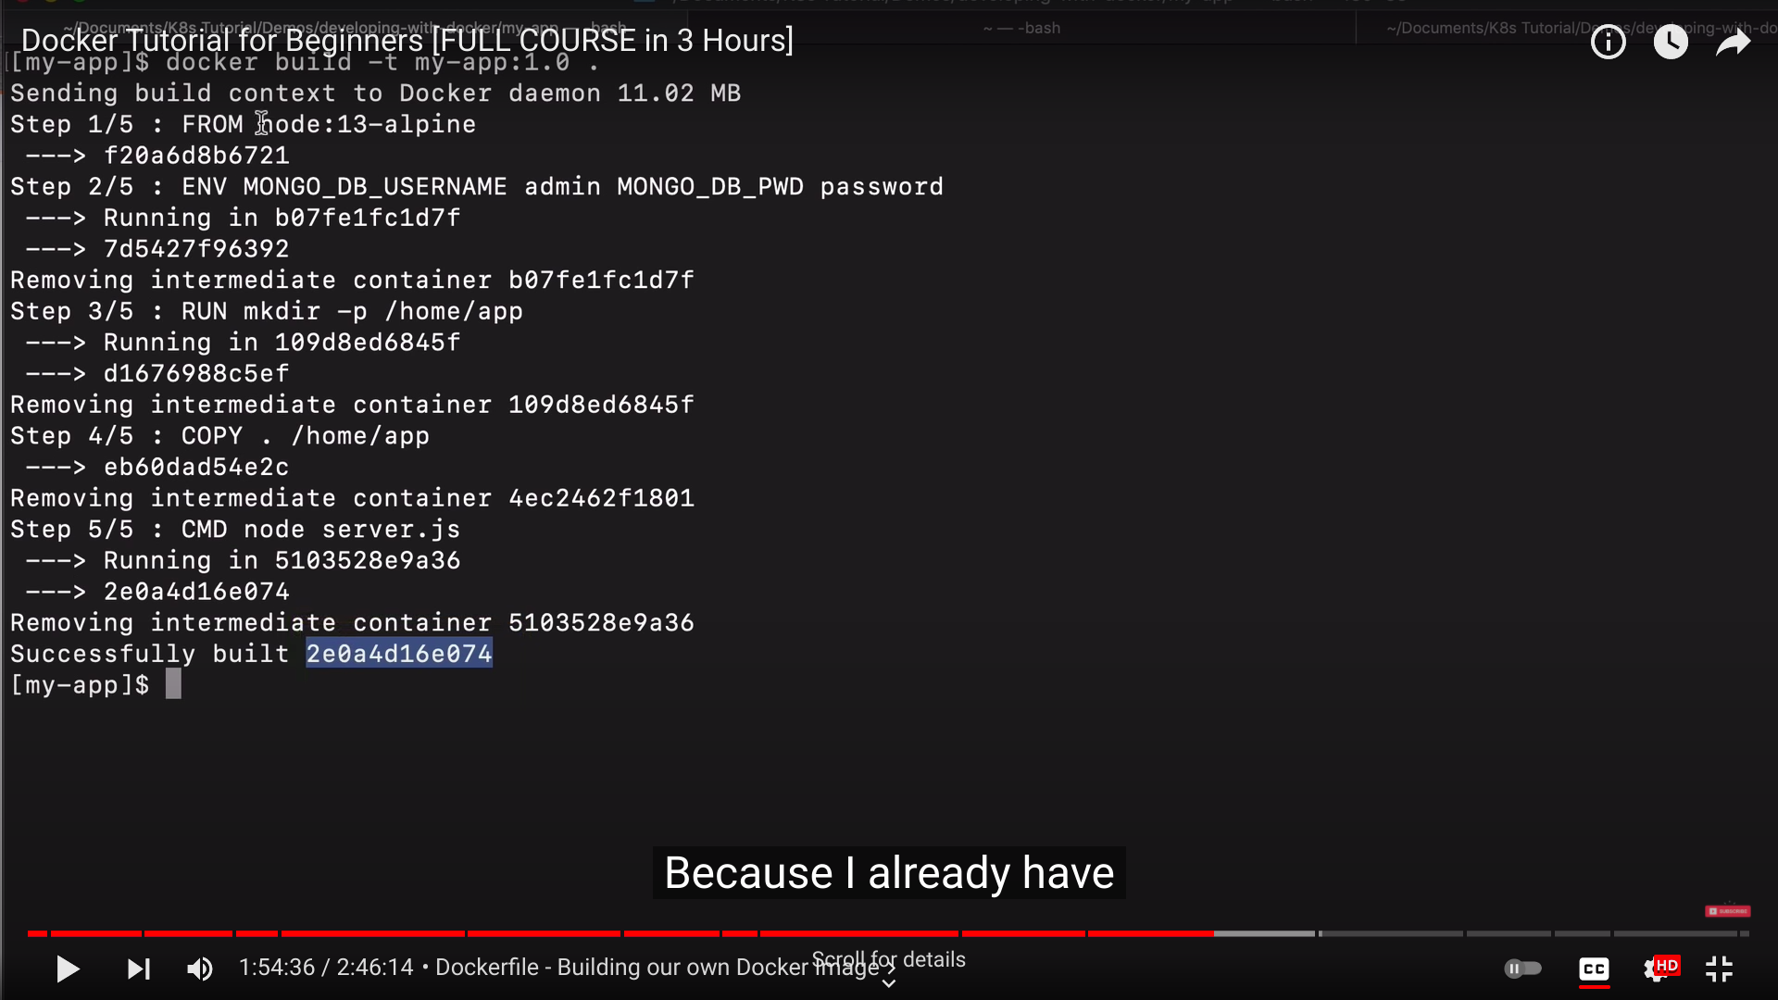

A Docker *registry* stores Docker images. Docker Hub is a public registry that anyone can use, and Docker is configured to look for images on Docker Hub by default. You can even run your own private registry.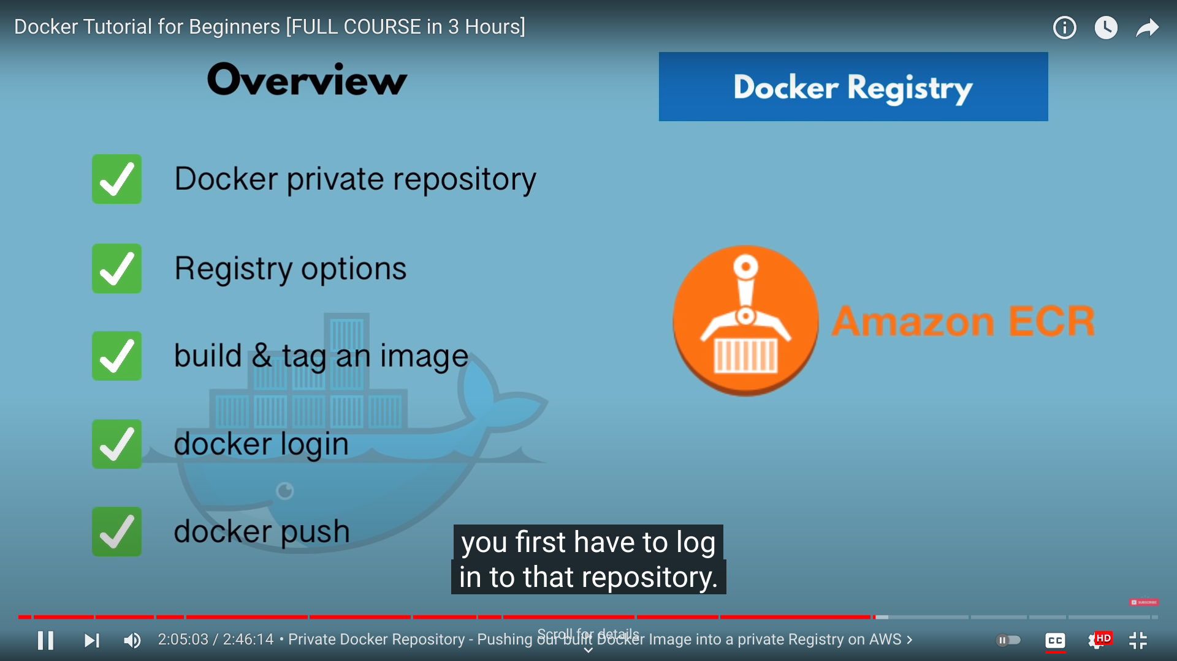

Create repository on aws to store registries.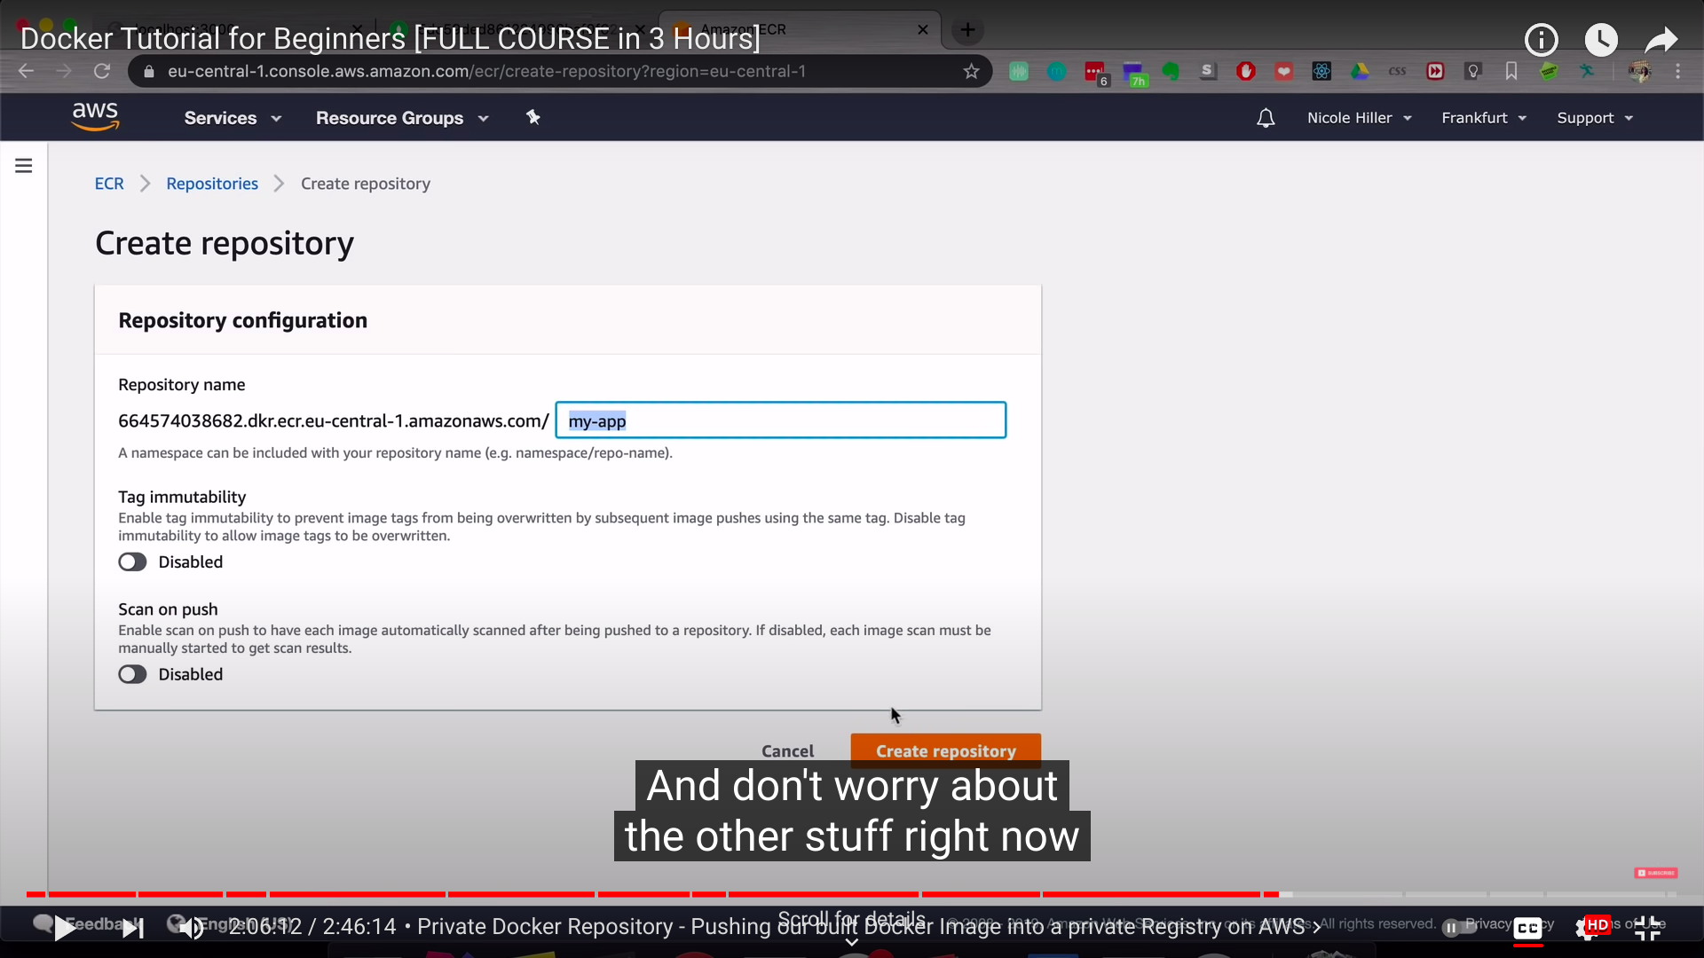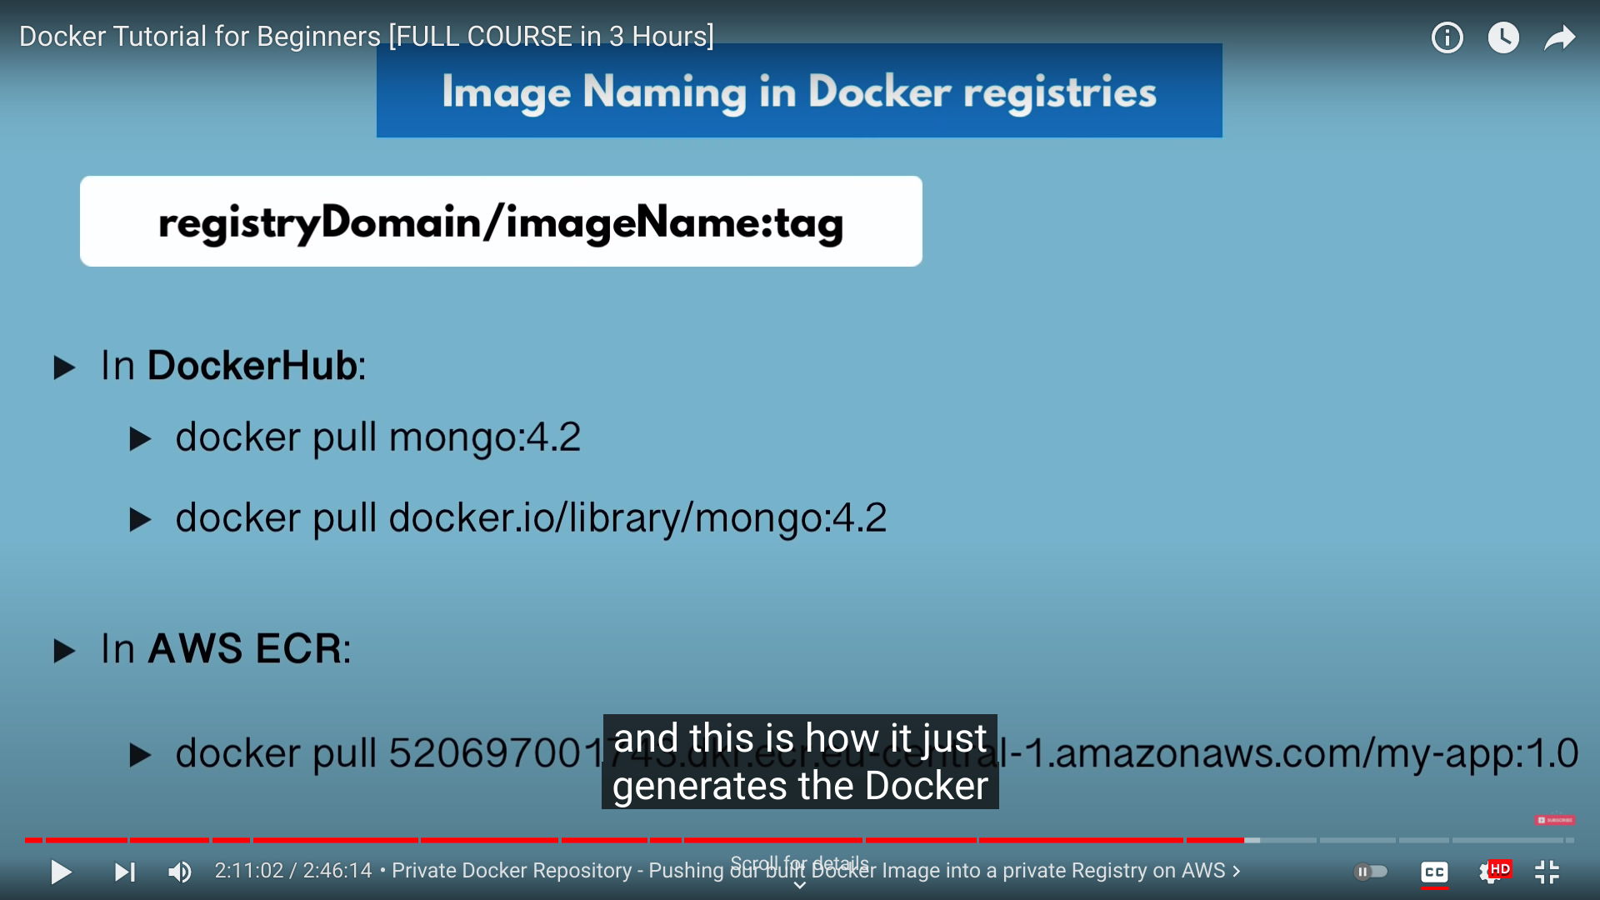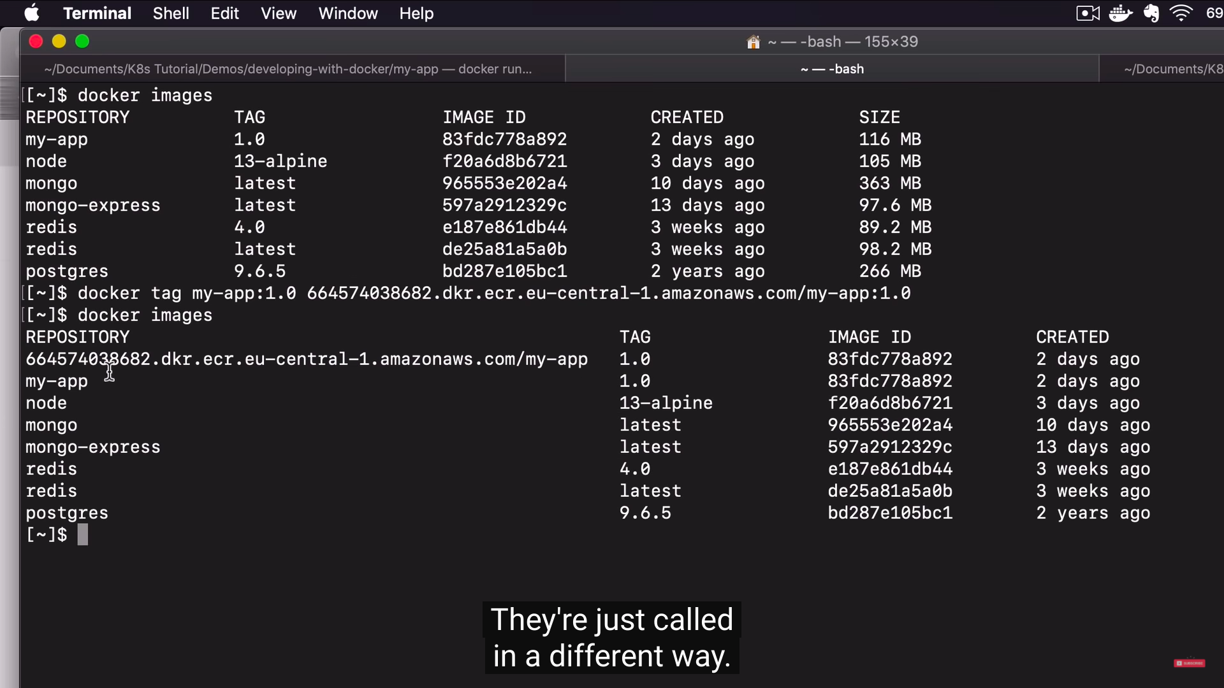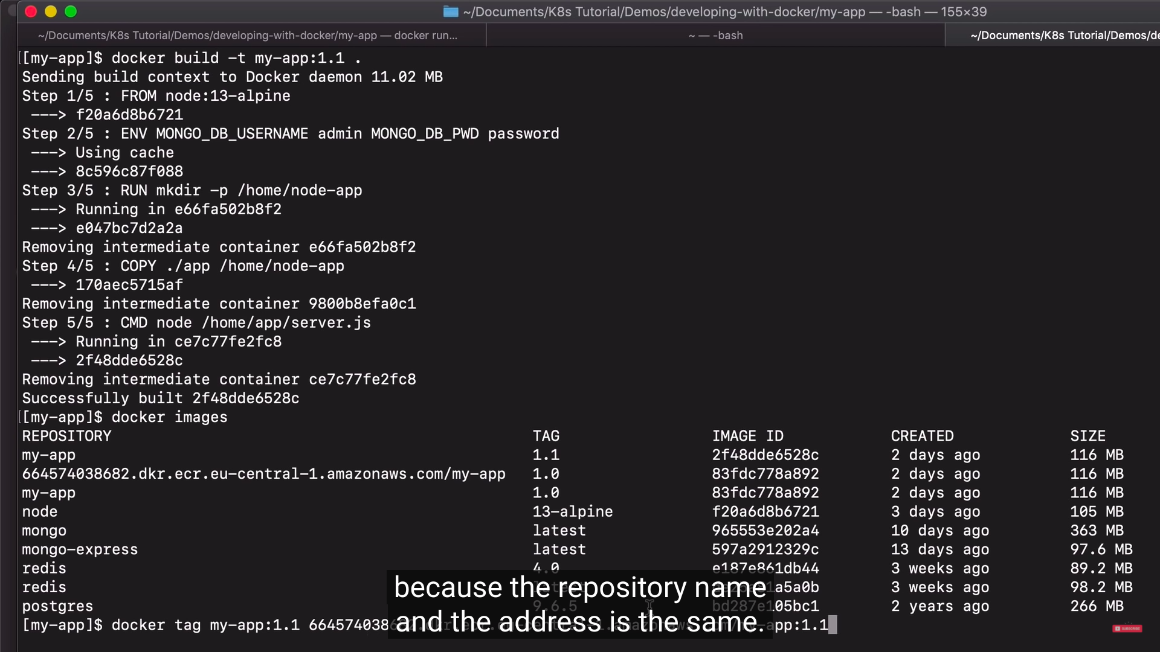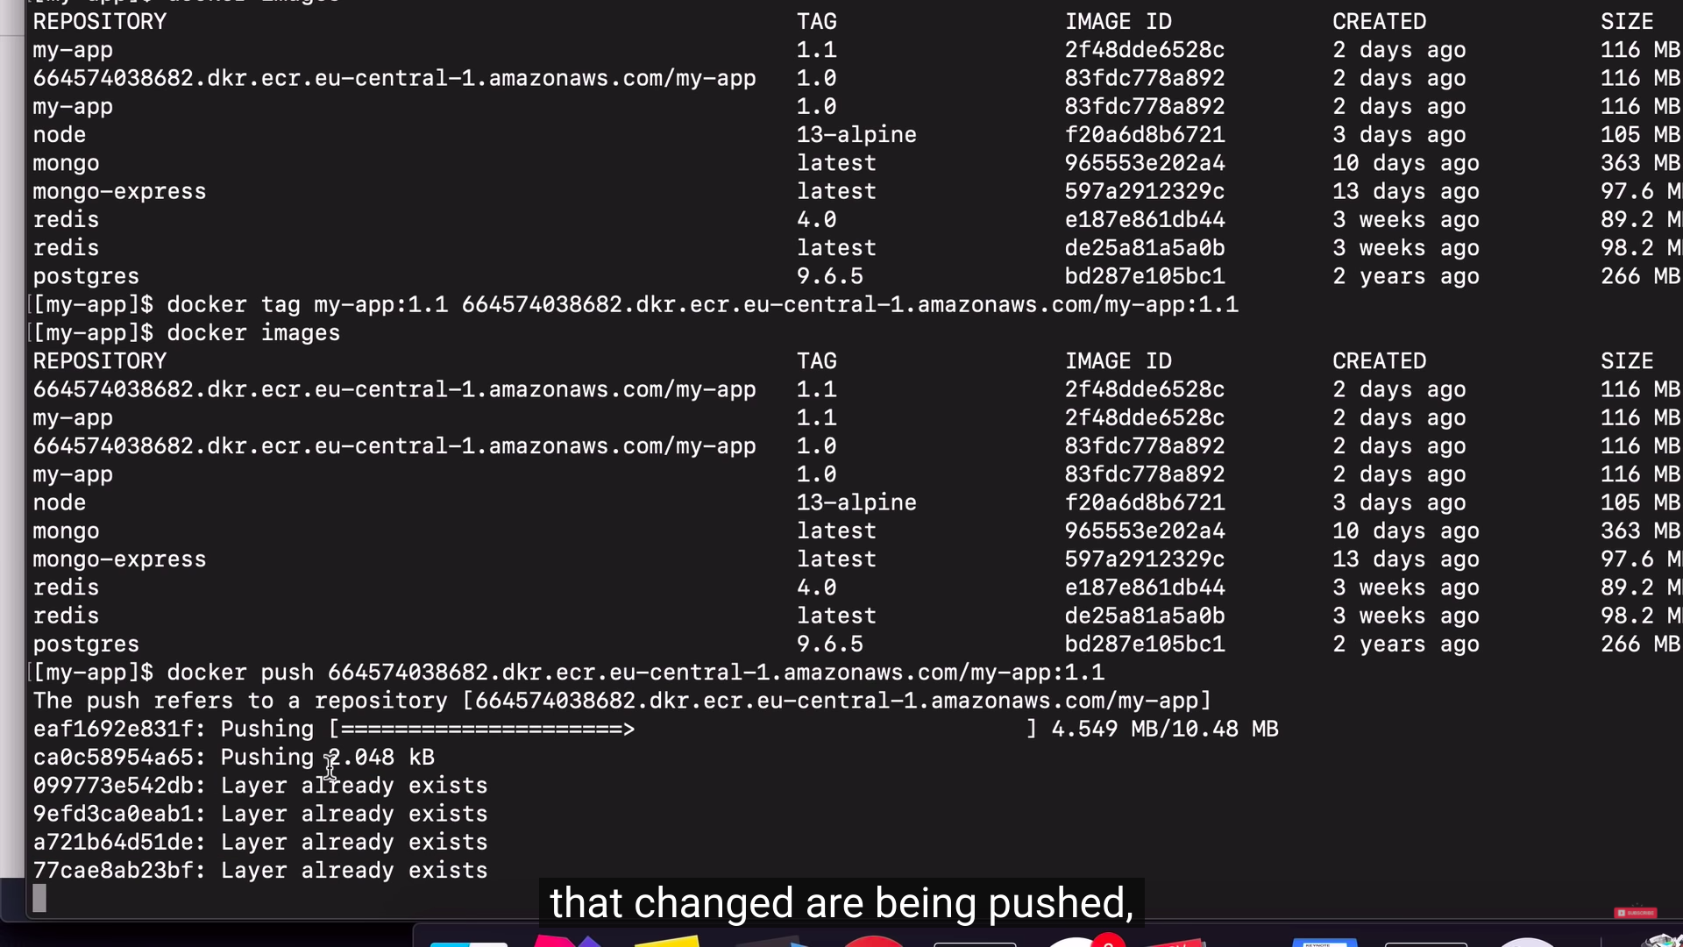

**Docker Volumes**

Docker volumes are **directories and files that exist on the host file system outside of the Docker container**.

And can be stored by docker run -v <path>.

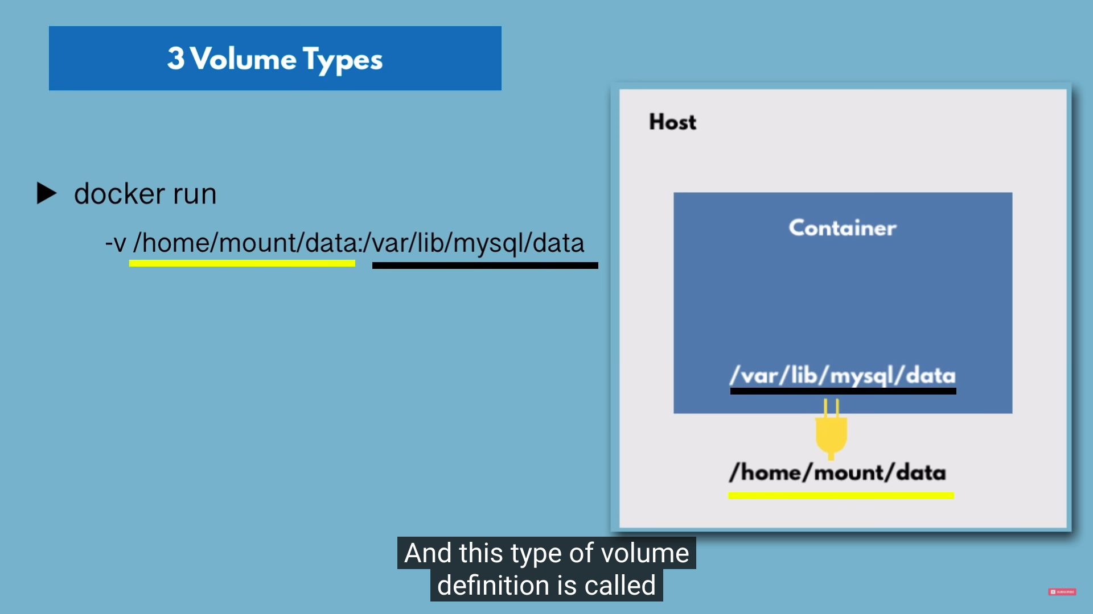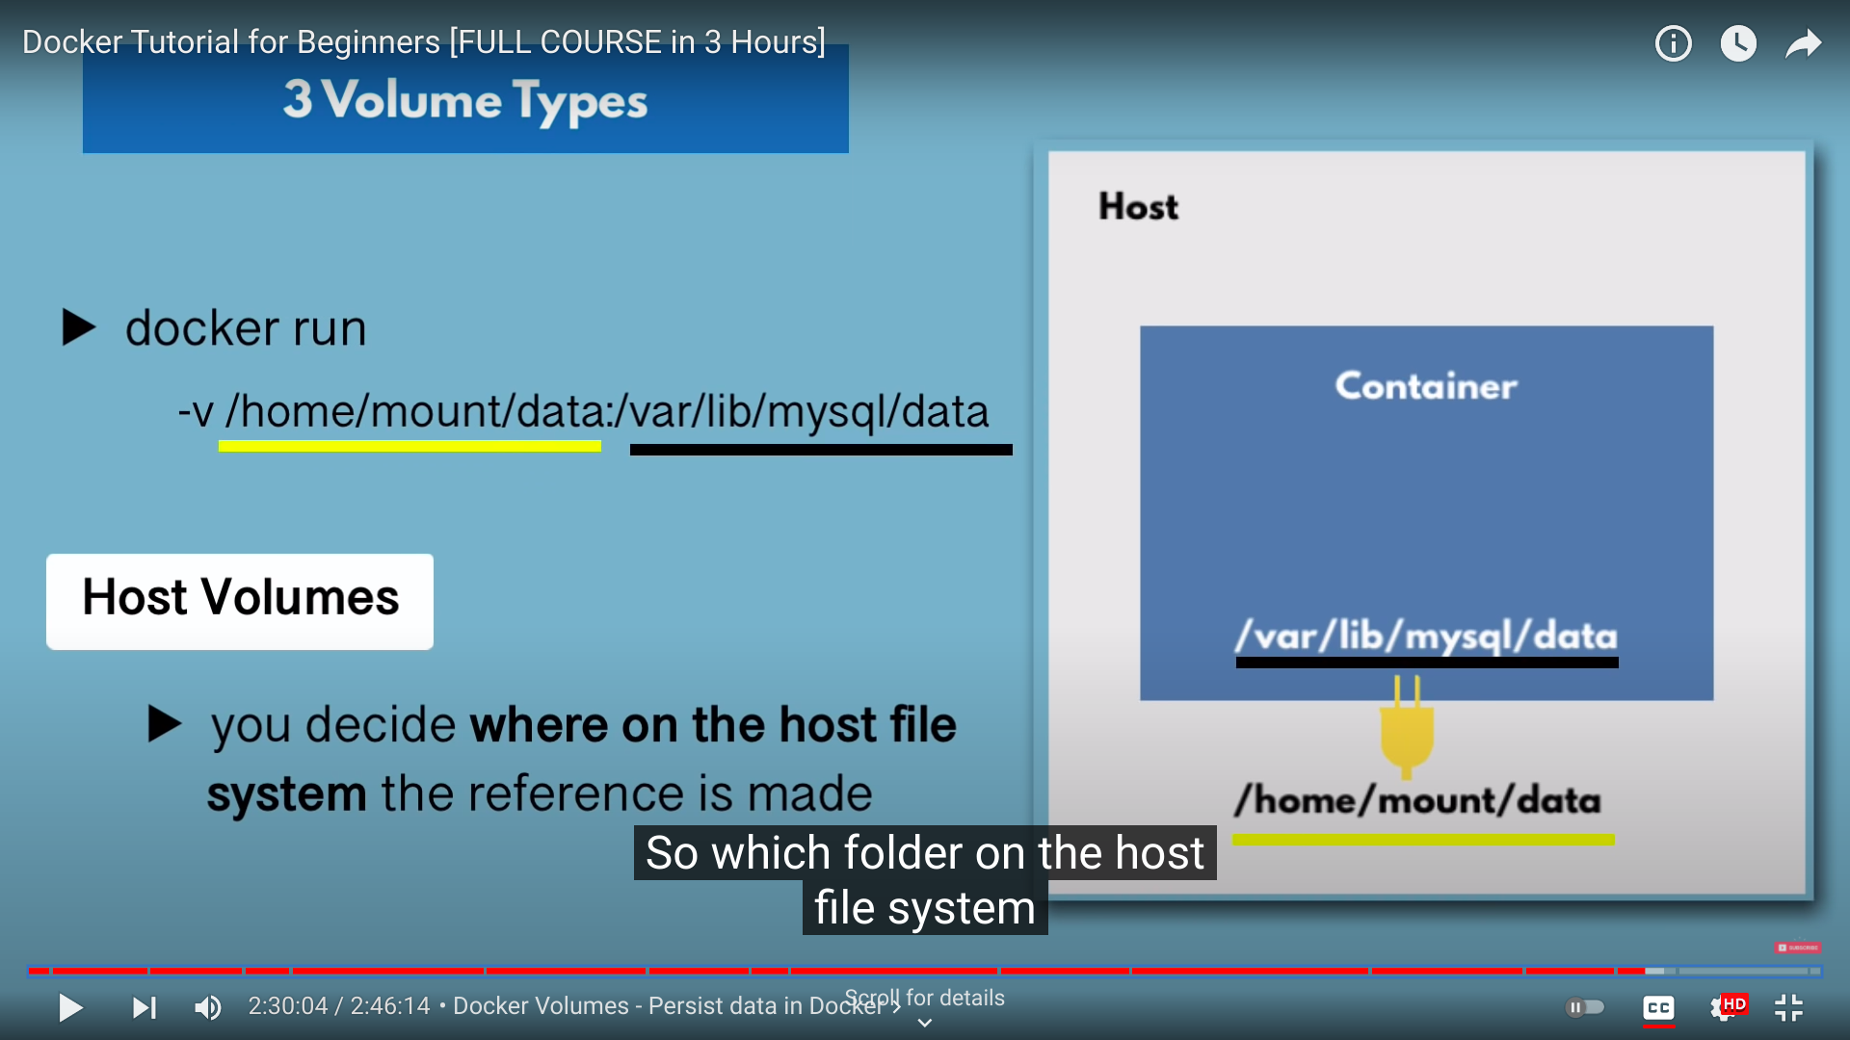

Container Files are located on host.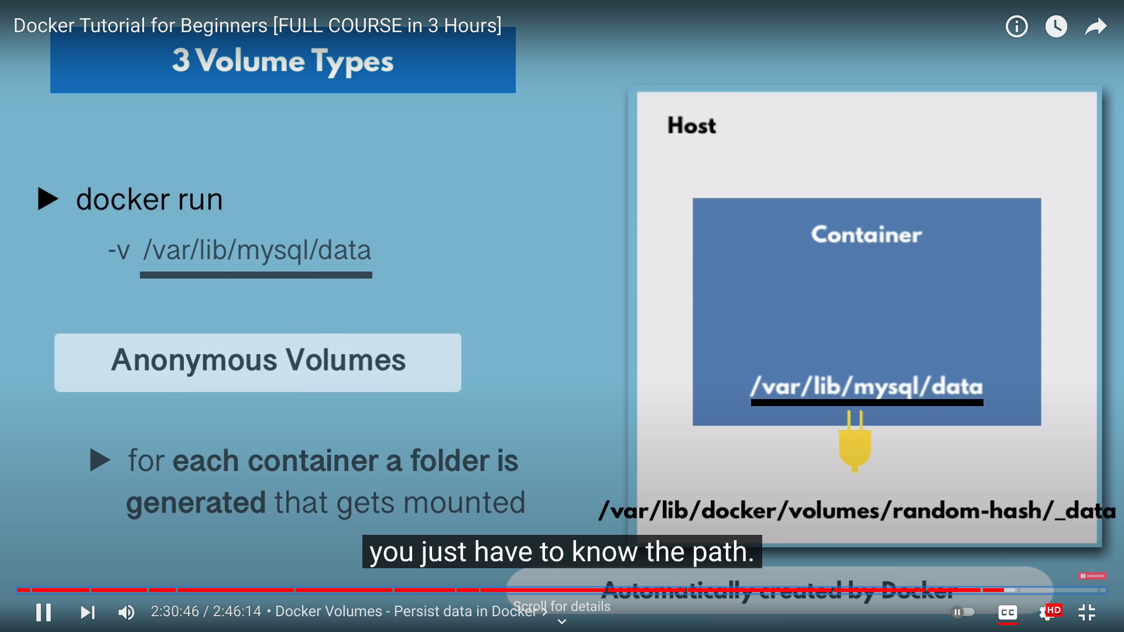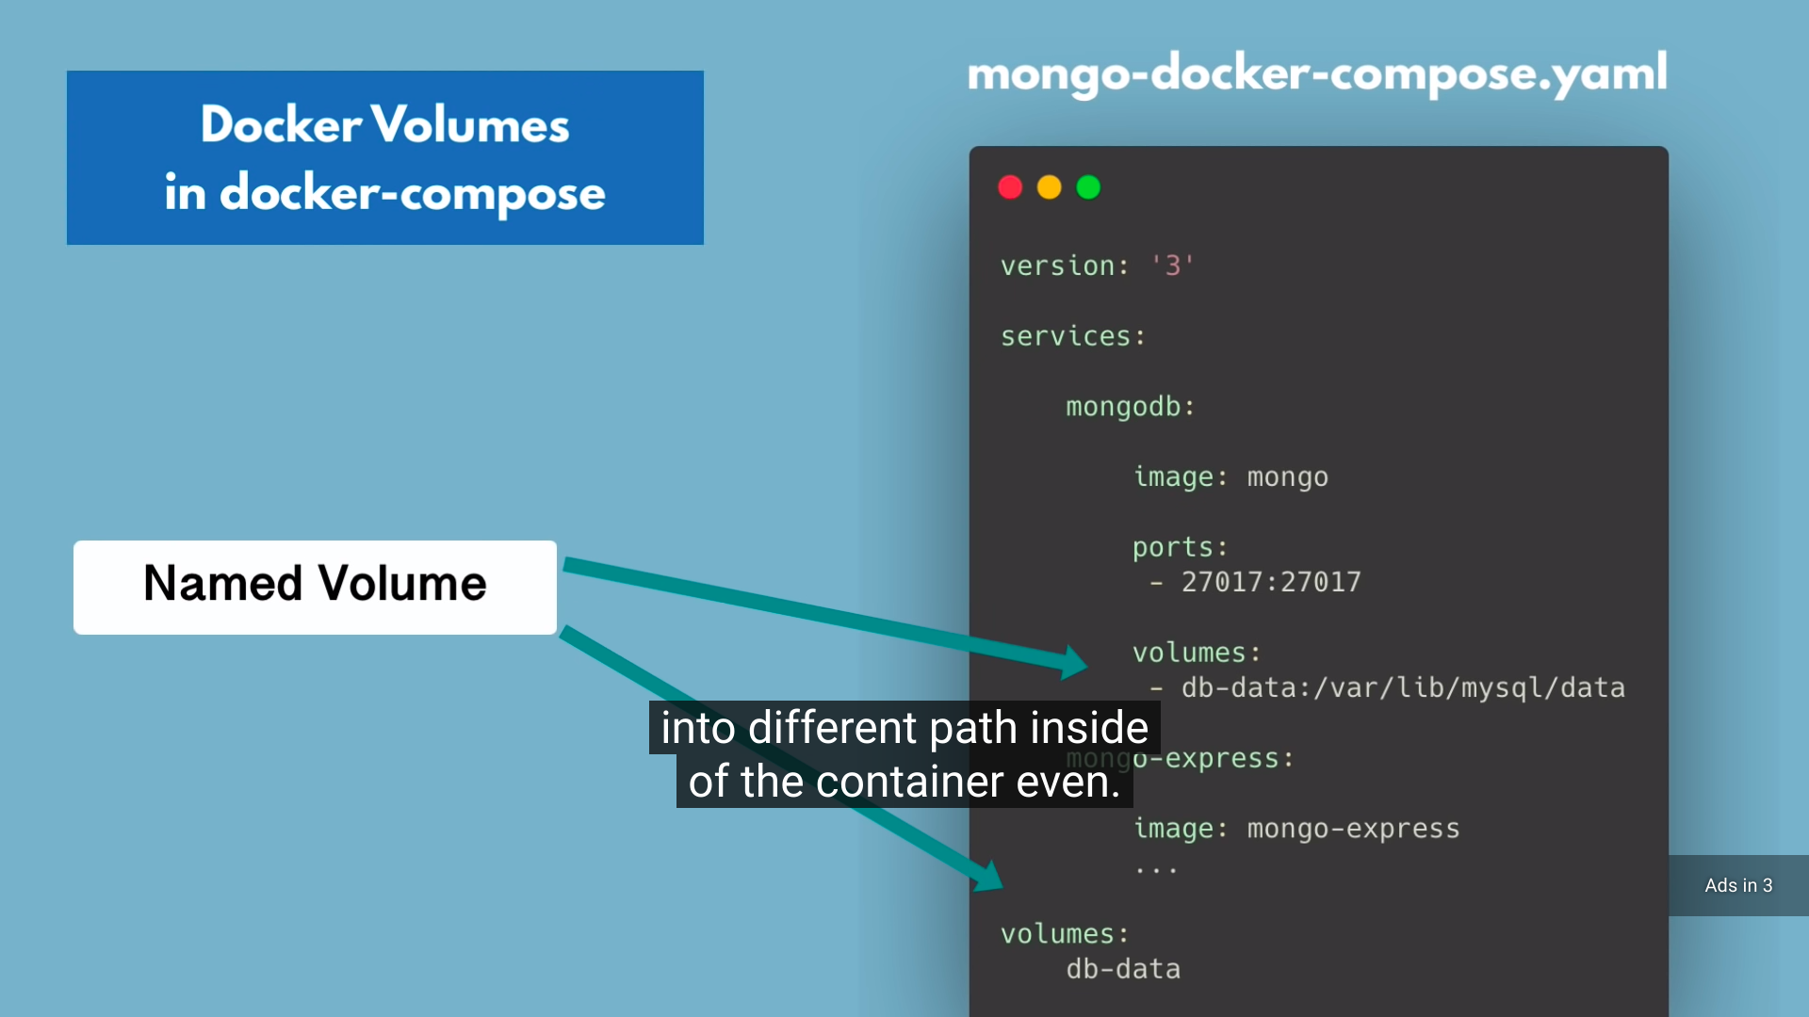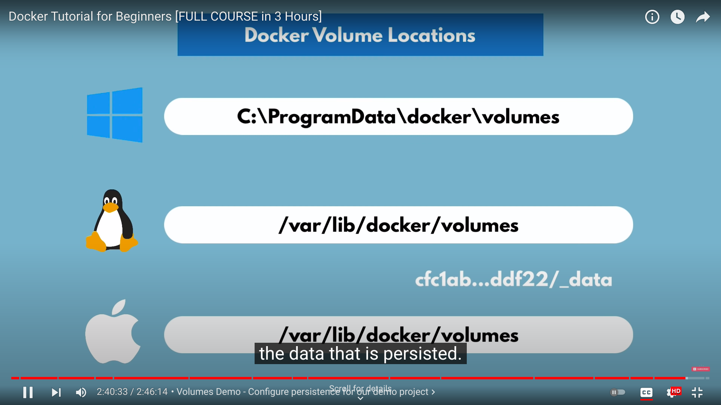

**Networking**

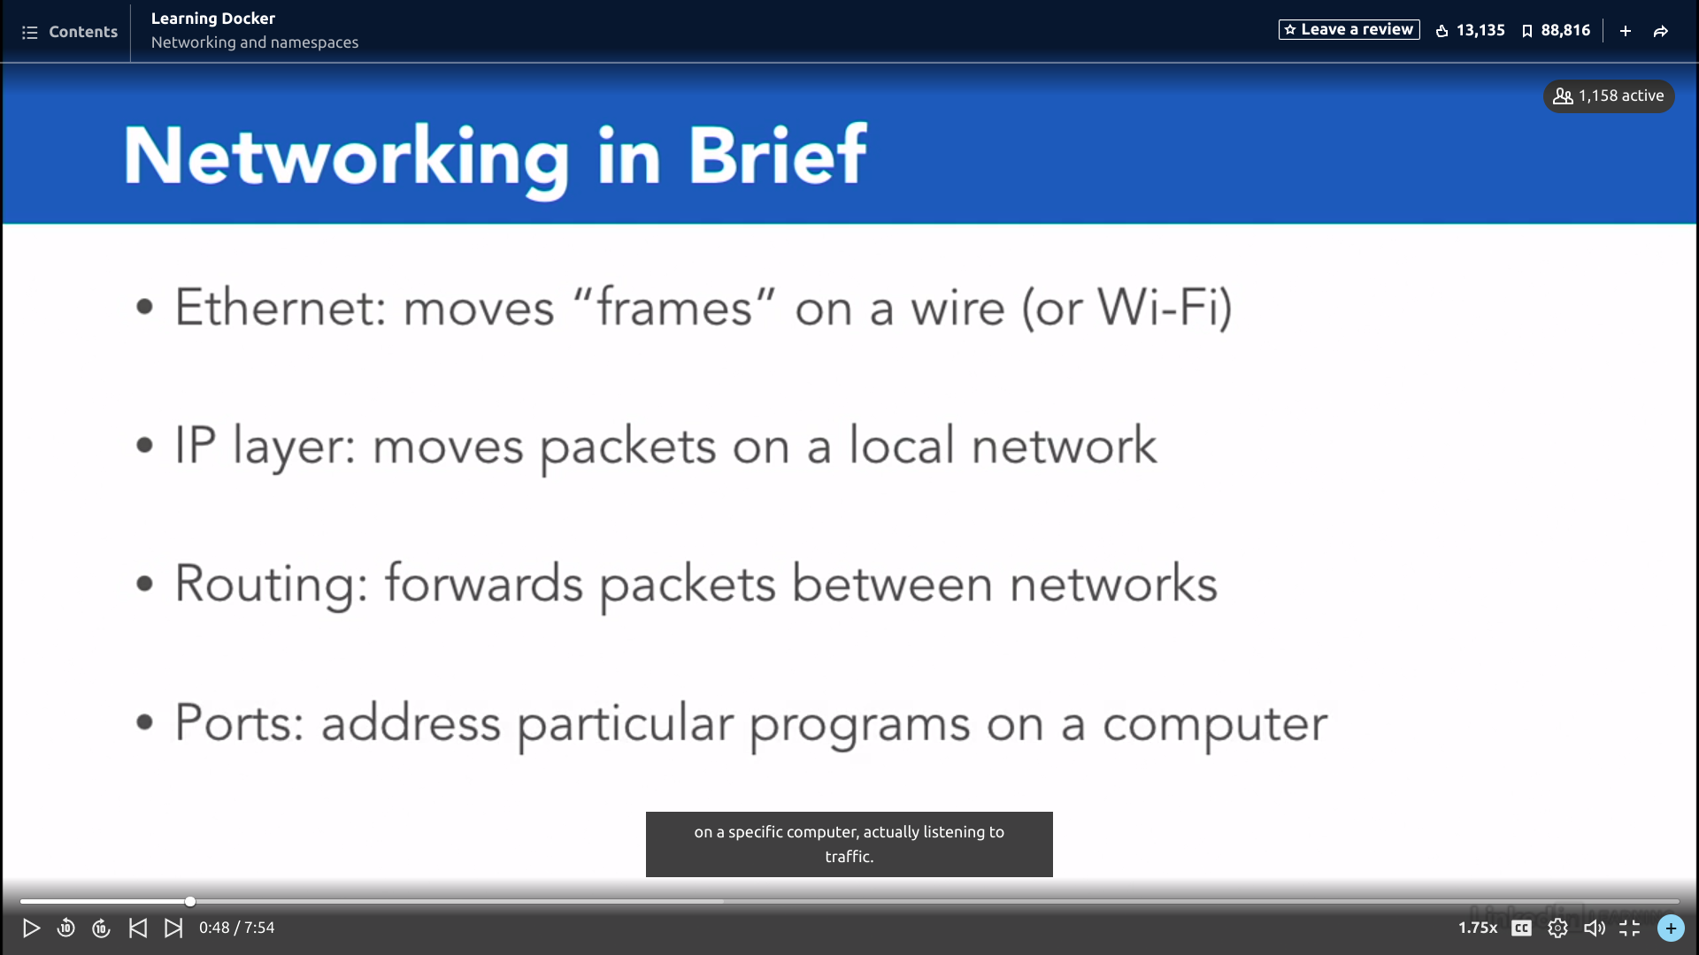

Bridging